Contents

1 Introduction 1

2 Model for trajectory clustering 3

3 Trajectory Distance 5

3.1 Warping based distance 5

3.1.1 DTW 6

3.1.2 LCSS 7

3.1.3 Pros and Cons 8

3.2 Shape based distance 9

3.2.1 Fréchet distance 9

3.2.2 Hausdorff distance 10

3.2.3 Pros and Cons 11

3.3 HC-SIM 11

4 Clustering 13

4.1 Methods 14

4.1.1 K-means 14

4.1.2 DBSCAN 15

4.1.3 Hierarchical Clustering 17

4.1.4 Other Methods 21

4.2 Quality Criteria 24

4.2.1 Silhouette Coefficient 27

4.2.2 Pair Sets Index 27

5 Experiments 29

5.1 Ground Truth Data 29

5.1.1 Data 29

5.1.2 Trajectory Similarity 32

5.1.3 Analysis of the distances 33

5.1.4 Clusters Validation 38

5.2 Unknown Data 48

5.2.1 Data 48

5.2.2 Analysis of the distances 49

6 Conclustions 59

List of Tables

1. Internal Validation Indexes . . . . . . . . . . . . . . . . . . . . . . 24
2. External Validation Indexes . . . . . . . . . . . . . . . . . . . . . 26
3. Mopsi Data structure . . . . . . . . . . . . . . . . . . . . . . . . . 32
4. Mopsi Silhouette Scores . . . . . . . . . . . . . . . . . . . . . . . 39
5. Caltrain Silhouette Scores . . . . . . . . . . . . . . . . . . . . . . 49

List of Figures

1. Trajectories with varying lengths . . . . . . . . . . . . . . . . . . 2
2. Clustering Methods . . . . . . . . . . . . . . . . . . . . . . . . . . 3
3. A GPS trajectory with 7076 points (Qian & Lu, 2017). . . . . . . 4
4. Euclidean distance . . . . . . . . . . . . . . . . . . . . . . . . . . 5
5. DTW distance . . . . . . . . . . . . . . . . . . . . . . . . . . . . . 7
6. LCSS . . . . . . . . . . . . . . . . . . . . . . . . . . . . . . . . . . 8
7. Fréchet distance . . . . . . . . . . . . . . . . . . . . . . . . . . . . 9
8. Hausdorff distance . . . . . . . . . . . . . . . . . . . . . . . . . . 10
9. Distances calculated by Hausdorff and Fréchet (Besse et al., 2015) 11
10. C-SIM . . . . . . . . . . . . . . . . . . . . . . . . . . . . . . . . . 12
11. DBSCAN (Su et al., 2020) . . . . . . . . . . . . . . . . . . . . . . 15
12. The distance threshold *r* defines the neighborhood of a point.

(Ertöz et al., 2003) . . . . . . . . . . . . . . . . . . . . . . . . . . 16

1. Hierarchical clustering models (Bian et al., 2019) . . . . . . . . . 17
2. HAC clustering (Sultana, 2020) . . . . . . . . . . . . . . . . . . . 19
3. Ward Linkage (Ignacio Gonzalez et al., 2017) . . . . . . . . . . . . 20
4. K-means* algorithm (Malinen et al., 2014) . . . . . . . . . . . . . 21
5. Fast density peaks algorithm (Sieranoja & Fränti, 2019) . . . . . . 22
6. Grid Structure example (Q. Zhao et al., 2015) . . . . . . . . . . . 23
7. Pairing by Hungarian . . . . . . . . . . . . . . . . . . . . . . . . . 28
8. Mopsi Trajectories . . . . . . . . . . . . . . . . . . . . . . . . . . 30
9. Mopsi Clusters . . . . . . . . . . . . . . . . . . . . . . . . . . . . 31
10. Overview of our process . . . . . . . . . . . . . . . . . . . . . . . 32
11. DTW Trajectories Clustering . . . . . . . . . . . . . . . . . . . . 33

|  |  |
| --- | --- |
| 24 LCSS Trajectories Clustering . . . . . . . . . . . . . . . . . . . . | 34 |
| 25 Hausdorff Trajectories Clustering . . . . . . . . . . . . . . . . . . | 35 |
| 26 Fréchet Trajectories Clustering . . . . . . . . . . . . . . . . . . . | 36 |
| 27 HCSIM Trajectories Clustering . . . . . . . . . . . . . . . . . . . | 37 |
| 28 Silhouette Score depending on cluster . . . . . . . . . . . . . . . . | 38 |
| 29 Pair Sets Index based on distance . . . . . . . . . . . . . . . . . . | 42 |
| 30 Trajectories Clusters 1 . . . . . . . . . . . . . . . . . . . . . . . . | 43 |
| 31 Trajectories Clusters 2 . . . . . . . . . . . . . . . . . . . . . . . . | 43 |
| 32 Trajectories Clusters 3 . . . . . . . . . . . . . . . . . . . . . . . . | 44 |
| 33 Trajectories Clusters 4 . . . . . . . . . . . . . . . . . . . . . . . . | 44 |
| 34 Trajectories Clusters 5 . . . . . . . . . . . . . . . . . . . . . . . . | 45 |
| 35 Trajectories Clusters 6 . . . . . . . . . . . . . . . . . . . . . . . . | 45 |
| 36 Trajectories Clusters 7 . . . . . . . . . . . . . . . . . . . . . . . . | 46 |
| 37 Trajectories Clusters 8 . . . . . . . . . . . . . . . . . . . . . . . . | 46 |
| 38 Trajectories Clusters 9 . . . . . . . . . . . . . . . . . . . . . . . . | 47 |
| 39 Trajectories Clusters 10 . . . . . . . . . . . . . . . . . . . . . . . | 47 |
| 40 Caltrain Trajectories Dataset . . . . . . . . . . . . . . . . . . . . | 48 |
| 41 Silhouette Score . . . . . . . . . . . . . . . . . . . . . . . . . . . . | 49 |
| 42 Caltrain Clusters . . . . . . . . . . . . . . . . . . . . . . . . . . . | 53 |
| 43 Caltrain DTW Clusters . . . . . . . . . . . . . . . . . . . . . . . . | 54 |
| 44 Caltrain LCSS Clusters . . . . . . . . . . . . . . . . . . . . . . . . | 55 |
| 45 Caltrain Hausdorff Clusters . . . . . . . . . . . . . . . . . . . . . | 56 |
| 46 Caltrain Frechet Clusters . . . . . . . . . . . . . . . . . . . . . . . | 57 |
| 47 Caltrain HCSIM Clusters . . . . . . . . . . . . . . . . . . . . . . .  List of Equations | 58 |
| 1 Euclidean distance . . . . . . . . . . . . . . . . . . . . . . . . . . | 6 |
| 2 DTW distance . . . . . . . . . . . . . . . . . . . . . . . . . . . . . | 6 |
| 3 LCSS Similarity . . . . . . . . . . . . . . . . . . . . . . . . . . . . | 7 |
| 4 LCSS Distance . . . . . . . . . . . . . . . . . . . . . . . . . . . . | 8 |
| 5 Fréchet distance . . . . . . . . . . . . . . . . . . . . . . . . . . . . | 9 |
| 6 Hausdorff distance . . . . . . . . . . . . . . . . . . . . . . . . . . | 10 |
| 7 C-SIM . . . . . . . . . . . . . . . . . . . . . . . . . . . . . . . . . | 12 |
| 8 HC-SIM . . . . . . . . . . . . . . . . . . . . . . . . . . . . . . . . | 12 |
| 9 HC-SIM distance . . . . . . . . . . . . . . . . . . . . . . . . . . . | 13 |

|  |  |
| --- | --- |
| 10 Single Linkage . . . . . . . . . . . . . . . . . . . . . . . . . . . . . | 18 |
| 11 Complete Linkage . . . . . . . . . . . . . . . . . . . . . . . . . . . | 19 |
| 12 Average Linkage . . . . . . . . . . . . . . . . . . . . . . . . . . . . | 19 |
| 13 Ward Linkage . . . . . . . . . . . . . . . . . . . . . . . . . . . . . | 20 |
| 14 WB-Index . . . . . . . . . . . . . . . . . . . . . . . . . . . . . . . | 26 |
| 15 Silhouette Coefficient . . . . . . . . . . . . . . . . . . . . . . . . . | 27 |

Abstract

In the past few years, there has been a significant advancement in the development of location-based positioning devices, and an increasing number of moving objects and their trajectories are being captured. Thus, it follows that the subject of moving object trajectory clustering is certain to be of prime importance to researchers working on data mining on moving objects. To give a context, we look at how development and the current trend in moving object clustering is in and then review common cluster techniques presented in the past few years. In this thesis, we start off by summarizing the basic characteristics of trajectory. Second, we examine the metrics for determining the similarity/dissimilarity of two trajectories. Thirdly, we investigate the methods and implementation processes of conventional moving object clustering methods. Finally, the validation criteria used to assess the efficacy and efficiency of clustering algorithms are explored.

# Introduction

The increasing usage of integrated mobile devices integrate with GPS, WIFI and data storage hardware allows us to gather a massive quantity of data. Due to the intricacy of the collected data, extract useful information is a challenging problem to solve. Knowing principal routes that people or vehicles follow during the day can provide valuable information for analysis of mobility. For instance the presence of important routes not adequately covered by the public transport service could be highlighted by a set of trajectories, which provide information on how to improve it. Trajectory clustering is an appropriate way of analyzing trajectory data, and has been applied to road network extraction (MariescuIstodor & Fränti, 2018), (Ahmed et al., 2015) and (Biagioni & Eriksson, 2012), detecting taxi fraud (Liu et al., 2013), data compression (M. Chen et al., 2012) etc. Additionally, trajectory clustering is used to gather temporal spatial information in the trajectory data and is widespread used in many application areas, such as motion prediction (Z. Chen et al., 2010) and traffic monitoring (Atev et al., 2006)

Trajectory data is stored in a variety of forms based on the kind of device, the velocity of the object, and even the function. For instance, a GPS device generates a trajectory, which is a locations sequence in geographical space identified by a combination of coordinates and a time stamp. Additional object-related attributes such as direction, velocity, or geographic information may be added in certain cases (Ying et al., 2011, 2010). Multidimensional data is used in many different areas, for example, to better understand animal migratory patterns by examining animal trajectories, to help forecast the weather by analyzing hurricane data, to help athletes achieve higher levels of performance, and much more.

Measurement of how similar two trajectories are is a typical approach in a wide range of applications. As a result, the measurement of distances is necessary in many tasks and applications of trajectory analysis since it enables us to judge the similarity of two trajectories. The spacing between the trajectories must be properly determined. Because trajectories are high-dimensional data (a sequence of positions on a map/a time-series of positions on a time-line) that has both spatial and temporal qualities, they must be taken into consideration when doing calculations like distance measurements. Therefore, there are a number of distance metrics used for trajectory data. E.g., the term "measure the sequence-only

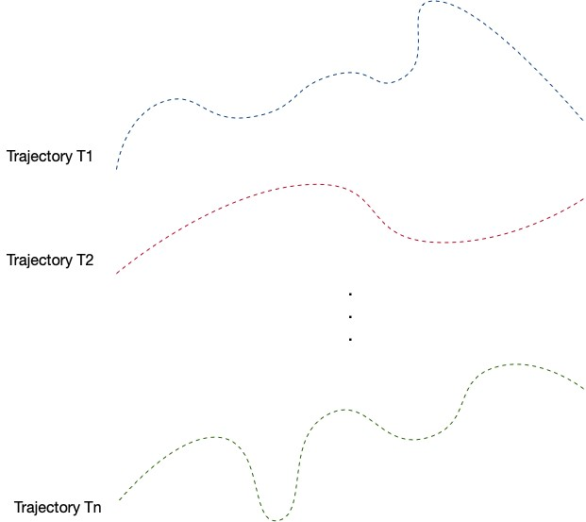

Figure 1: Trajectories with varying lengths

distance between trajectories" may include concepts such as Euclidean distance and Dynamic Time Wrapping Distance (DTW). Various approaches, including as clustering and classification, are often employed to identify valuable patterns from large volumes of trajectory data. Clustering is an unsupervised learning method that organizes data based on their distance (Han et al., 2011; R. Xu & Wunsch, 2005). Trajectories that occur in each cluster tend to be rather similar and distinct from those in other clusters (Berkhin, 2006; Besse et al., 2015; Yuan et al., 2017).

There are two primary methodologies used for data clustering like trajectories. Specify trajectory clustering algorithms first, then use generic clustering methods compare trajectory distance/dissimilarity. Density-based clustering (Kriegel et al., 2011) is one of the most ideal clustering methods for trajectories, since it can extract clusters of any form and is also tolerant to outliers (Ester et al., 1996). Density-Based Spatial Clustering of Applications with Noise (DBSCAN), is one of the most extensively used approaches in this group, which is commonly used (L. Zhao & Shi, 2019; Cheng et al., 2018; J. Chen et al., 2011; Lee et al., 2007). Fundamental to the clustering challenge is measuring similarity. In order to measure similarity (inverse distance), it should be done prior to grouping. The

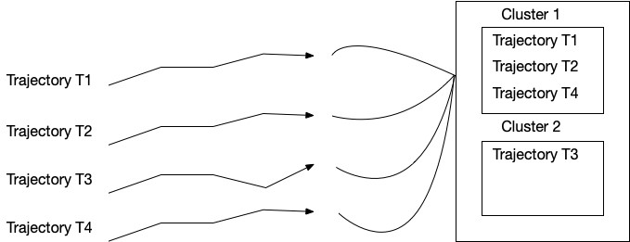

Figure 2: Clustering Methods

definition of distance in spatial trajectories is significantly complicated. Trajectories are non-linear sequences of points with vary length in multiple dimensions. Thus, in order to compare two trajectories a comprehensive approach is required to fully determine the distance between them. Different distance metrics are presented according to the analysis’s goal and the data type. Due to the domainspecific nature of the concept of similarity, distinct distance metrics are defined to address various aspects of similarity, those are temporal, spatio-temporal, and spatial. Euclidean, Fréchet, Hausdorff, DTW, and LCSS distances are the fundamental metrics in measuring similarity from which many additional metrics are derived (Abbaspour et al., 2017; Aghabozorgi et al., 2015; Wang et al., 2013).

# Model for trajectory clustering

A trajectory is a series of time-stamped data that captures the path of moving things, such as humans, cars, animals, and natural features. For example, Global Position System (GPS) tracking devices generating a trajectory as *Trajectory* = (*A,B,*··· *,Tn*), which is consecutive spatial space sequence of points, and *Ti* indicates a combination of coordinates and timestamps such as *Ti* = (*xi,yi,ti*).

Clustering methods are designed to aggregate similar trajectories into distinct groups. This is a challenging task due to the complicated of the trajectory, as objects within a particular region can take numerous paths. Clustering trajectories may be done in a variety of ways. We will focus on trajectory clustering based on distance, but have also investigated alternative techniques. In most situations, trajectory data is represented as a multidimensional (2D or 3D) time series as in Figure 3; Gaffney & Smyth (1999), Vasquez & Fraichard (2004). M. Chen et al. (2012) used GPS trajectory clustering for improving data compression. The continuous definition of trajectory also applies by Gariel et al. (2011) to re-sample trajectories to achieve equal-length time series. These new trajectories are then analyzed for the main components to obtain and finally cluster the primary components. The purpose is to group trajectories that follow similar paths. As clustering is focused on trajectories, and it necessitates a new distance measurement to define the similarity between them.

There has been considerable effort put into developing different trajectory distances. Numerous approaches have been employed to cluster trajectories from a data collection. Clustering techniques based on Euclidean distance provide erroneous results due to the fact that trajectories include a variable number of points. As a result, numerous warping distance-based techniques have been established.

Typical examples are distance measurements based on Dynamic Time Warping (DTW), and Longest Common Subsequence (LCSS), all of which reorder trajectories’ time index in order to obtain a perfect match. Another possibility is to concentrate on the shape of the trajectories. Hausdorff and Fréchet, for example, may be adapted to trajectories. In next section, we will study and compare several distances on trajectory.

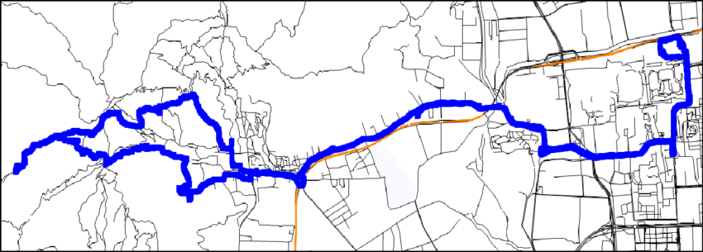

Figure 3: A GPS trajectory with 7076 points (Qian & Lu, 2017).

# Trajectory Distance

A trajectory distance generalization that consideres moving objects and it measures on average how close two objects were during some time period. *d*(*A,B*) represents the distance of two trajectories *AandB*. The greater the value, the less similarity between the two trajectories. Apart from the concept of mathematical distance, several measurements may be utilized to characterize this dissimilarity. Distances may be classified into two types: those based on the geometry of the trajectory (Shape-based distances) and those that consider temporal dimension (Warping based distance).

## Warping based distance

In the 1960s, Euclidean distance was suggested to calculate distance between time series, and now, during the last several decades, has been recognized to be one of the most commonly used distance functions (Keogh & Pazzani, 2000; Faloutsos et al., 1994; Pfeifer & Deutrch, 1980; Priestley, 1980).

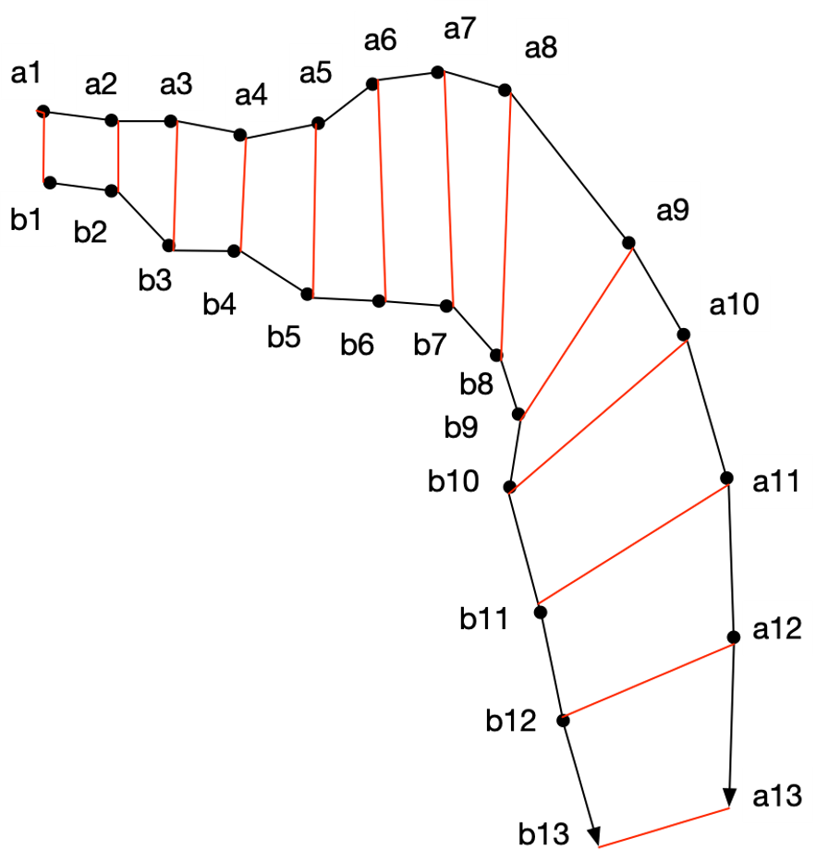

Figure 4: Euclidean distance

The Euclidean distance *dEuclidean*(*A,B*) between trajectories *AandB* with the same size *n* is define as follows:

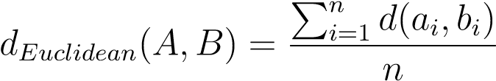 (1)

Where *ai* and *bi* are the ith sample point of two trajectories *A* and *B*. The time complexity of Euclidean distance is *O*(*n*).

The Euclidean distance measure is simple to understand; however, it is only accurate if the compared trajectories are of equal size, which is not likely to be the case in practical applications. The primary objective in warping distance is to resolve this issue. The dynamic time warping algorithm (DTW) (Kruskal, 1983) and the longest common subsequence algorithm (LCSS) (Kearney & Hansen, 1990) were introduced to increase the accuracy. While both distances are specified identically, they use distinct cost functions.

### DTW

*Dynamic time warping* (DTW) is similarity method for comparing two sequences. In the beginning, Myers et al. (1980) developed DTW to calculate time-series distance. In 1980s, DTW was introduced to measure trajectory distance (Kruskal, 1983) and has become one of the most extensively method for measuring trajectory distance. DTW explores all point alignments between two trajectories in search of the distance which is minimum.

Specifically, the DTW distance *dDTW* (*A,B*) between two trajectories *A* and *B* is defined as:



0∞*,if n,if n*= 0= 0*and mor m* = 0= 0

*dDTW* (*A,B*) = (2)

*d*(*Head*(*A*)*,Head*(*B*)) + *min*{*dDTW* (*A,Rest*(*B*))*,* *dDTW* (*Rest*(*A*)*,B*)*,dDTW* (*Rest*(*A*)*,Rest*(*B*)} *otherwise*



With *Head*(*A*) denotes *a*1, *Rest*(*A*) denotes {*a*2*,...,an*} in case trajectory *A* is consists of GPS points {*a*1*,...,an*}. *n*, *m* are trajectories *A* and *B* lengths.

DTW’s time complexity is *O*(*mn*).

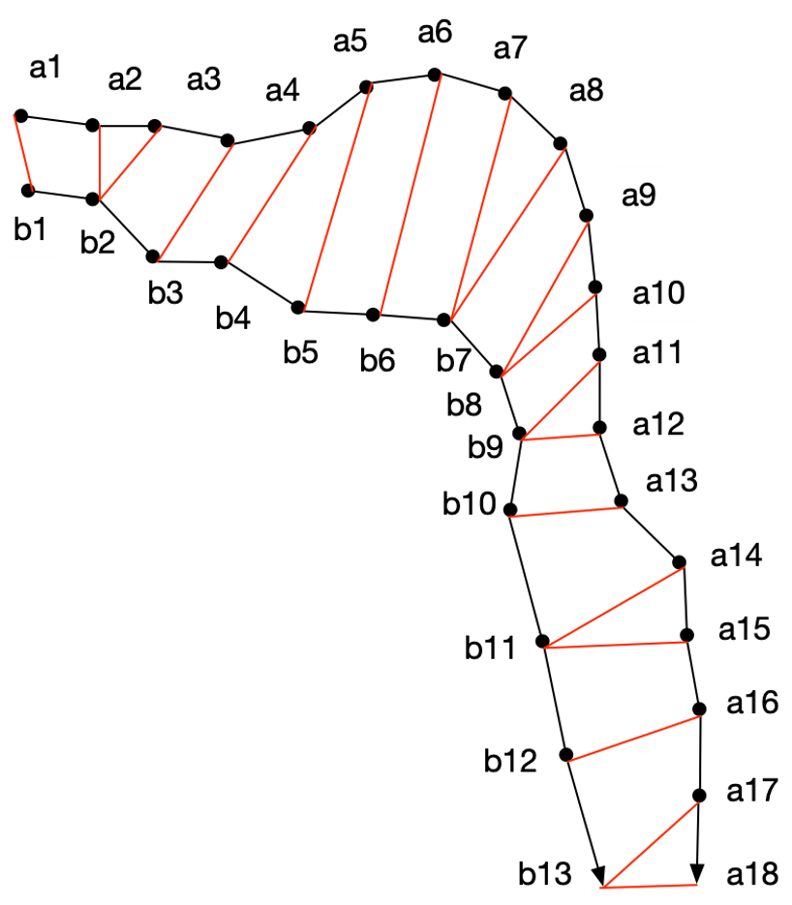

Figure 5: DTW distance

### LCSS

*Longest common subsequence* (LCSS) is well-known method for measuring string similarity that searches the longest common sub-sequence between two strings. For example, for two sequences ’ABCD’ and ’ACBAD’, their longest sub-sequences are ’ABD’ and ’ACD’. Because a trajectory may be considered as a series of sample points, LCSS was used to compare the similarity of trajectories. However, it is difficult to identify two sample points with the identical geographical information.

When comparing trajectories *AandB*, LCSS considers *ai* (*ai* ∈ *A*)*andbj* (*bj* ∈ *B*) to be the same if the their distance is less than a threshold . Therefore, we will ignore some sample points of *AandB* which are too far apart to contribute.

In contrast to Euclidean distance, LCSS is robust to noise. LCSS similarity is defined as:

 0*,* if *n* = 0 or *m* = 0



s*LCSS*(*A,B*) = 1 + LCSS(Rest(*A*)*,*Rest(*B*))*,* if *d*(Head(*A*)*,*Head(*B*)) ≤ *ε*

 max(LCSS(Rest(*A*)*,B*)*,*LCSS(*A,*Rest(*B*)))*,* otherwise

(3)

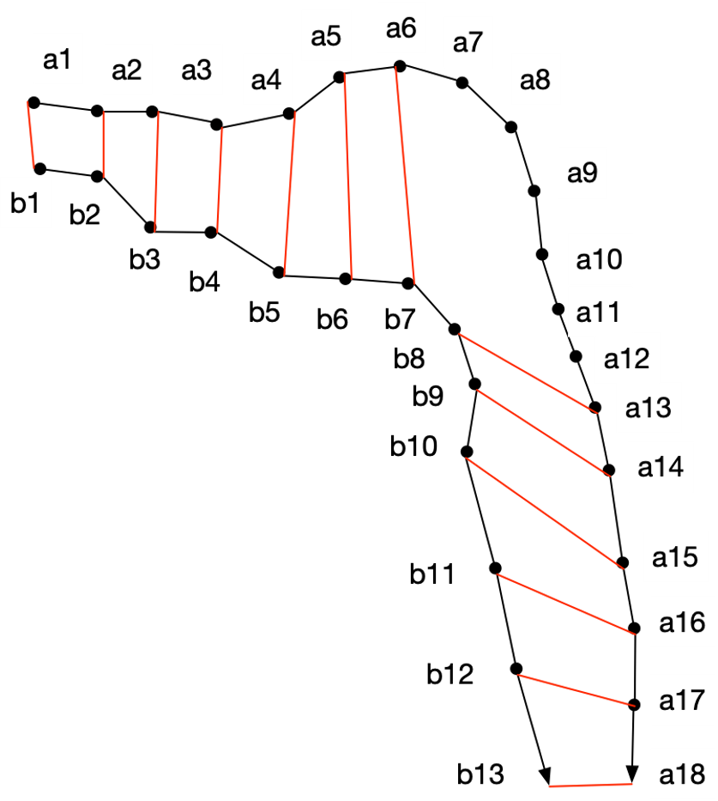

Figure 6: LCSS

LCSS is similarity so we will calculate distance:

*dLCSS*(*A,B*) = 1 − *sLCSS*(*A,B*) (4)

### Pros and Cons

DTW and LCSS enable to compare different length trajectories.

However, there are two major drawbacks to using warping-based distance:

* In general, warping methods compare sequences one-to-one so choosing a series as a reference for other sequences is necessary. Two sequences must be well-balanced in order to detect changes in time series such as when there was acceleration and deceleration. Therefore, the sequence to be referenced must be carefully selected.
* Due to the inherent noise in traffic data, traditional warping-based methods cannot obtain accurate results when examining time series.

## Shape based distance

Instead of matching the trajectory sample points, these distances compare shape of trajectories. This indicates that trajectories are clustered regardless of their location. The most well-known distances are the Hausdorff and Fréchet.

### Fréchet distance

The Fréchet distance (Eiter & Mannila, 1994) is a method measure similarity between curves consider both the location and sequence of points. The Fréchet distance between the two curves is the shortest length of leash necessary for both paths to be traversed.

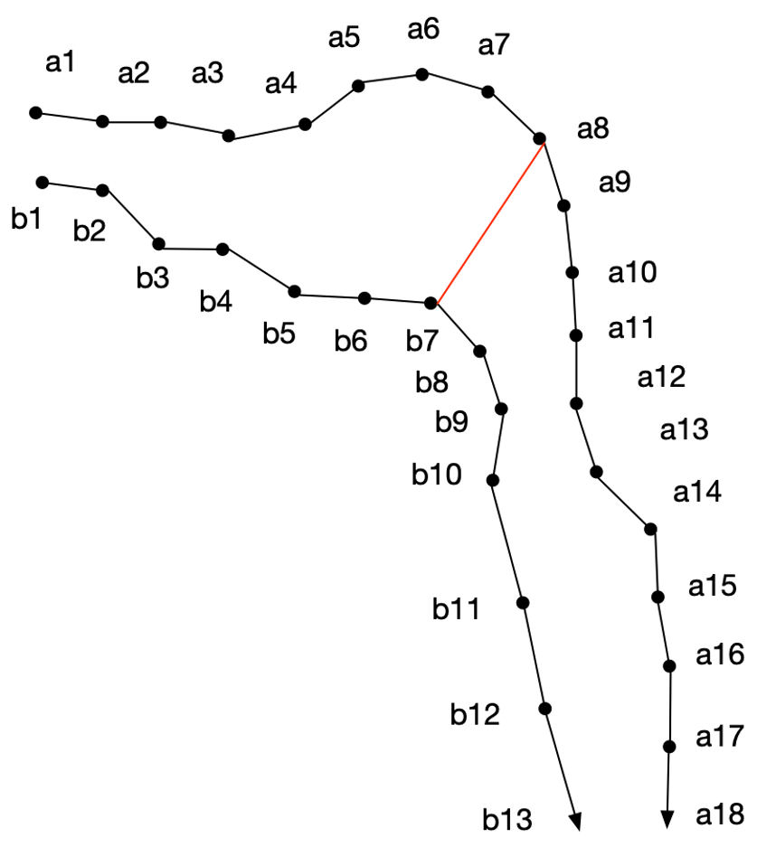

Figure 7: Fréchet distance

The Fréchet distance algorithm is shown below:

*dFrechet*(*A,B*) = *infmaxtin*[*t.start,t.end*]{*d*(*fa*(*t*)*,fb*(*t*))} (5)

*fa andfb* denote as two continuous functions of two trajectories *AandB* over time *t*, *t.start* and *t.end* denote starting time and end time of time period *t* respectively. The Fréchet distance between *AandB* is defined as the infimum over all reparameterizations *fa*(*t*) and *fb*(*t*). Fréchet distance is affected by variations in sampling rate and is susceptible to noise since it is the longest distance between two trajectories at the same time.

Fréchet distance’s time complexity is *O*(*mn*).

### Hausdorff distance

The Hausdorff distance measures the distance between two sets of metric spaces. The Hausdorff distance is a metric distance which calculates the distance between two subsets of a metric space. It is the maximum distances from a point in one set to the closest point in the other set.

The Hausdorff distance algorithm is shown as:

 (6)

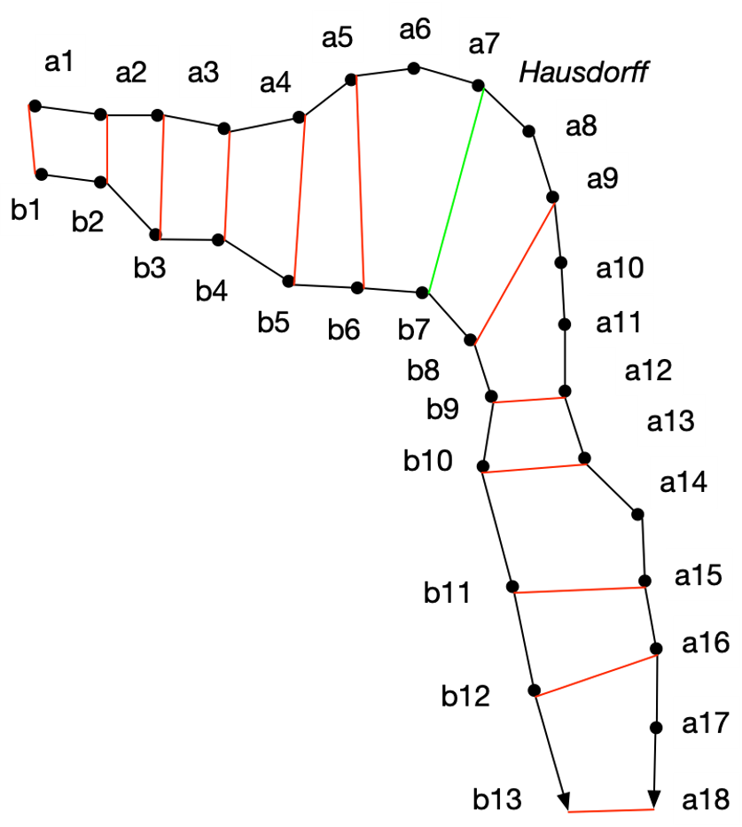

Figure 8: Hausdorff distance

The Hausdorff distance’s time complexity is *O*(*n*2).

### Pros and Cons

Both the Fréchet and Hausdorff distances are metrics, which means they correspond to the triangle inequality. If we want the clustering methods like DBSCAN or K-medoid to be efficient, we need this property of the distance. They’ve been used in a number of areas where shape comparison is required. However, it may be difficult to do a comprehensive comparison of trajectories. Both distances return the greatest distance between two trajectories at particular moments.

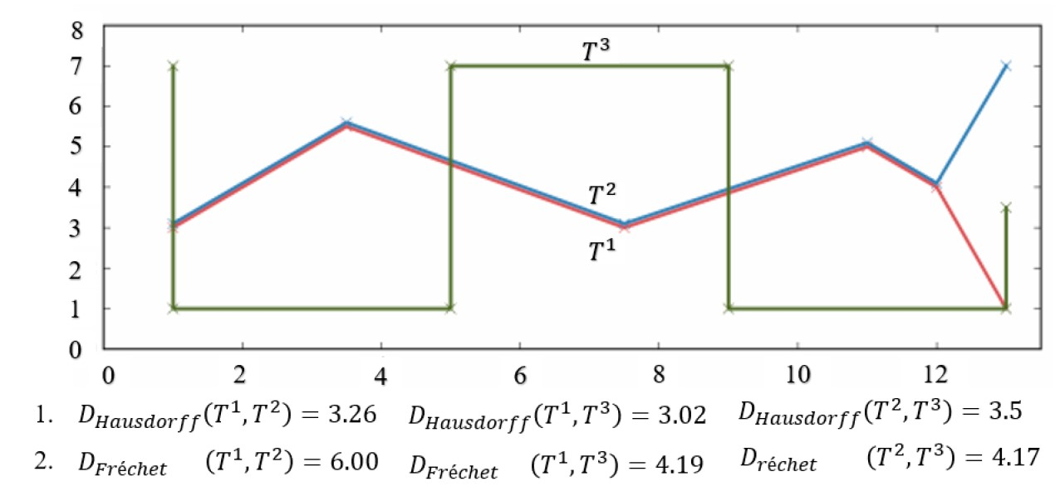

Figure 9: Distances calculated by Hausdorff and Fréchet (Besse et al., 2015)

As in Figure 9, we can see that *T*1 and *T*2 are the most comparable of the three trajectories, yet they are the furthest apart in Fréchet due to the maximum distance of trajectory end at 6. And the Hausdorff distances for all trajectories are nearly identical, implying poor precision. These two approaches are effective in applications involving shape comparisons, such as image comparison.

## HC-SIM

Fränti & Mariescu-Istodor (2021) proposed a new shape-based distance, HC-SIM (Hierarchical Cell Similarity), an independent variant of C-SIM measure. We will evaluate HC-SIM in this thesis and compare it with other distances. HC-SIM are proposed as it is least impacted by sample rate changes and works well with noise.

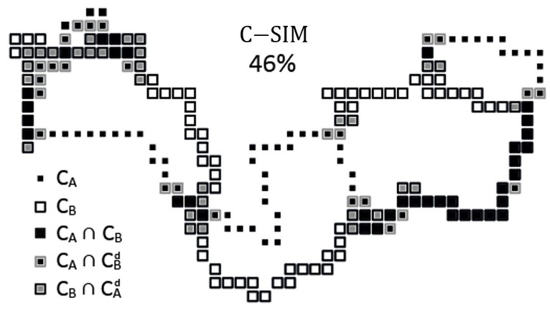

Figure 10: C-SIM

C-SIM algorithm was proposed by Mariescu-Istodor & Fränti (2017) to compute similarity of two trajectories. It computes a cell representation for the two trajectories using a grid, and determines the proportion of cells that are in common with the total cells.

C-SIM:

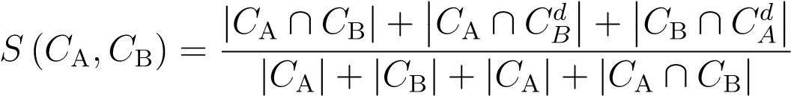 (7)

The C-SIM time complexity is *O*(*NA* + *NB* + |*CA*| + |*CB*|) where *NA* and *NB* are the number of trajectories’ points.

HC-SIM implements a grid featuring six layers (0.5%, 1%, 2%, 4%, 8%, and 16%). At each layer, we calculate how many cells shared by two segments to the total number of cells they occupy. In this thesis, we calculate HC-SIM distance through dissimilarity measure:

HC-SIM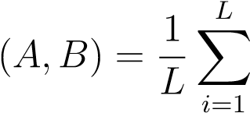C-SIM(*A,B*) (8)

*d*HC-SIM(*A,B*) = 1 − HC-SIM(*A,B*) (9)

# Clustering

Clustering is the most common unsupervised learning method in pattern recognition. It is basically the task of grouping objects such that similar objects reside in the same group together. Clustering algorithms have gained a lot of attention among researchers and therefore, a large number of clustering algorithms have been evolved. In order to be successful with clustering, first we need to understand the nature of the objects we need to cluster. We need to examine their properties and understand how these objects are inputted to an algorithm. For instance, one may be interested to know whether the data that needs to be clustered is inputted to the algorithm incrementally. This is an interesting problem when data is collected as clusters are evolving. On the other hand, the data set can be present as a whole prior to the execution of the clustering algorithm. Additionally, the properties of the objects that need to be clustered are very important. These properties can give rise to a number of important questions such as if the objects are vector-based or if the objects are metric based. Moreover, one needs to know if objects can be transformed from one form to another so that further analysis can be done on them. One of the most important aspects of clustering is a way of comparing the objects which is widely known as a distance function.

In this section, we will explore clustering algorithms and make an attempt to show which clustering algorithm is reasonable for trajectory clustering. We first start off with some prerequisites that many clustering algorithms require and show that these requirements are met by the trajectory distance function.

## Methods

### K-means

K-means is the well-known unsupervised machine learning technique for partitioning data set into k clusters, where k is pre-defined number of clusters. It classifies objects into number of clusters that objects in the same cluster are similar while objects from other clusters are dissimilar. K-means represents each cluster by its center (also known as the centroid) which match to the mean of data points.

The primary principle underlying k-means clustering is to define clusters that sum of square errors (SSE) or total within-cluster variation is minimized.

The K-means algorithm is summarized as follows:

* Define the number of clusters (k).
* Randomly select k objects from the data set as the initial cluster centroids.
* Allocates each observation to the closest cluster.
* Compute the centroids for the clusters by calculating the mean of the all data points that belong to each cluster.
* Loop through steps 3 and 4 until the cluster assignments stay unchanged.

K-means is a simple algorithm. By using a better initilization method and restarting k-means, it can be significantly enhanced (Fränti & Sieranoja, 2019). Furthermore, it can effectively deal with extremely huge data sets. However, the k-means clustering has several drawbacks. One drawback is that we must predetermine the number of clusters. Another drawback is sensitive to outliers and ordering of the data. Additionally, (Fränti & Sieranoja, 2018) showed that when cluster size unbalance, k-means performs badly.

Balanced clustering is expected in many applications. Networking, for example, uses balanced clustering to minimize imbalanced energy consumption (Siavoshi et al., 2016). And in traveling salesman problem, cities were clustered that each salesman in a cluster has an equal workload (Nallusamy et al., 2010). Furthermore, balanced clustering tends to avoid the emergence of outlier clusters (S. Zhong & Ghosh, 2003). Balanced K-means (Malinen & Fränti, 2014) is a general algorithm, which minimizes mean square error (MSE). The algorithm is same as K-means but cluster sizes are equal. Instead of using linear programming in assignment phase, Malinen & Fränti (2014) used Hungarian algorithm (Burkard et al., 2012) to solve the problem.

While K-means is an excellent technique for fine-tuning at the local level, it has significant limitations when clusters do not overlap.

### DBSCAN

Density-based clustering is a well-established subject of research with a straightforward concept: build a structure that properly represents the underlying density with a collection of data points (Kriegel et al., 2011). Based on this idea, Density-based spatial clustering of applications with noise (DBSCAN), is suggested by Ester et al. (1996) has been broadly applied to trajectory clustering. The basic concept is the density of the surrounding neighborhood must be greater than a certain threshold.

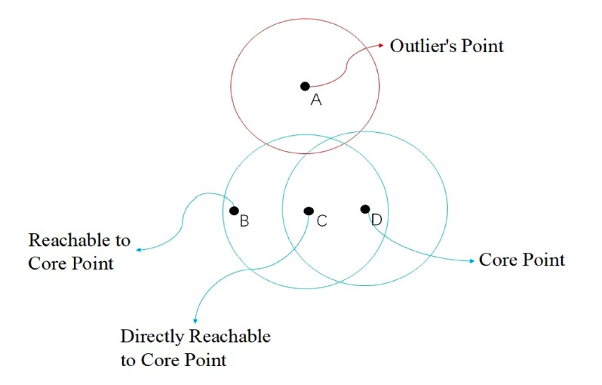

Figure 11: DBSCAN (Su et al., 2020)

The DBSCAN method (Ester et al., 1996; Kriegel et al., 2011) detects all clusters by expanding each cluster’s core points to any density-reachable points. It takes an arbitrary point *p* as its starting point and generates its -neighborhood. If it is a core point, it will initiate a new cluster, which will be enlarged by include all points in its vicinity. If a neighboring core point is discovered, the search is widened to encompass all points in the vicinity. The cluster is considered full when not discovered further core points in the extended neighborhood, and scan the remaining points to whether start a new cluster. After all points have been processed, those that have not been allocated are considered as noise.

DBSCAN has difficulty when handling data sets that have clusters of varied density. (Ertöz et al., 2003). For exaple in Figure 12. If the threshold is set too low, all of the points in the dense cluster will be considered noise. If the threshold is set too high, all scores will be grouped together. An alternative option would be to repeat the algorithm many times, eliminating previously discovered clusters after each run.

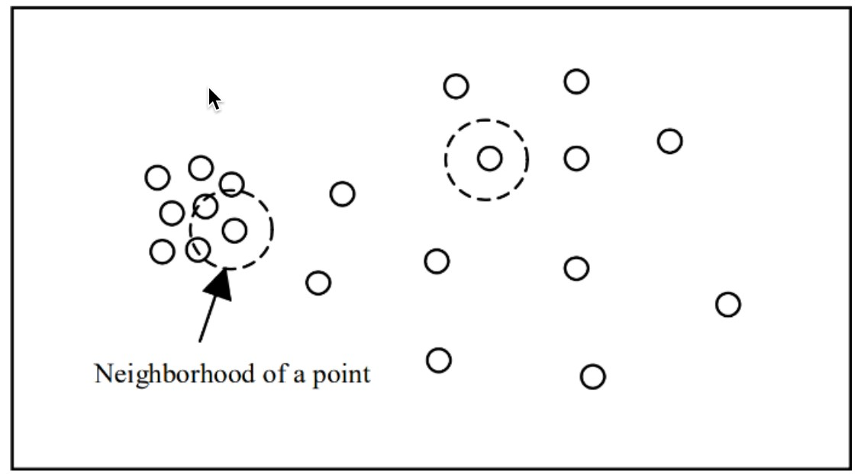

Figure 12: The distance threshold *r* defines the neighborhood of a point. (Ertöz et al., 2003)

The clustering technique must satisfy the trajectory object’s characteristics in order to be chosen. A mean trajectory cannot be easily defined since trajectories differ in length. Neither the k-means nor spectral clustering techniques are applicable to our trajectory collection. A valid metrics are required when implement an efficient algorithms like as partitioning around medoids or the DBSCAN. The majority of the investigated distances, such as LCSS and DTW, have not been classified as metrics so we will not use DBSCAN or medoid partitioning technique in this case. To cluster trajectories, we will use hierarchical cluster analysis (HCA). Actually, in HCA, only the distance/similarity matrix is required, which means objects of varied lengths can be clustered. In this thesis, we will use HCA to cluster trajectories and validate our distances.

### Hierarchical Clustering

As the name suggests, hierarchical clustering algorithms (Jain et al., 1999) produce a hierarchical representation of the data. Such hierarchical data representations are normally stored in a tree data structure. Each node of the tree is considered to be a cluster. The root of the tree is at the highest level and it contains all the elements. The root of the tree can be viewed as a single cluster. Each internal node of the tree contains children and each child can be interpreted as a single cluster. Assuming that the entire dataset is given in advance, there are two basic strategies:

* Agglomerative (bottom-up)
* Divisive (top-down)

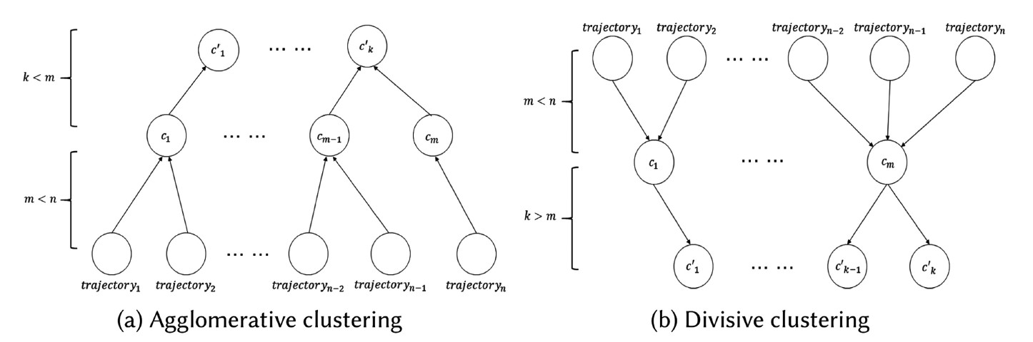

Figure 13: Hierarchical clustering models (Bian et al., 2019)

The agglomerative approach starts at the bottom of the tree. Each object is inserted to a leaf node representing a single cluster containing a single object. The algorithm proceeds by merging similar object by constructing internal nodes containing several nodes from the previous level. This is done recursively until there is a single node which defines the root of the tree.

The divisive approach works is opposite direction. Unlike the agglomerative approach, the divisive approach starts off by creating the root of the tree. The algorithm continues by dividing the entire dataset into two subsets of similar objects. This approach is also recursive. The recursion continues until the division process reaches a subset with a single node.

In this section, we focus on HAC (Hierarchical Agglomerative Clustering) as an example of the hierarchical clustering algorithm. The main idea is to give some insight of how such algorithms are designed. This is also beneficial because the reader will have an idea of what these tree data structures may look like. Assuming that we are given a dataset with *n* objects to cluster. HAC starts by creating a cluster for each object and then it performs *n* − 1 merges. The two most similar clusters are merged together at each step. These merges form new internal nodes of the tree containing more objects. Notice that when two nodes are being merged together, the algorithm needs to have a dissimilarity measurement between clusters. This means that the distance function is not enough. However, the cluster dissimilarity measure is derived from the provided distance function. HAC clustering may use one of the following ways as shown in Figure 14 to compute the merge cost:

* Single Linkage
* Complete Linkage
* Average Linkage
* Ward Linkage

The dissimilarity measurement is a derivation of distance function. Let *G* and *H* be two clusters, the single linkage (SL) measurement is the least distance between any two objects, *g* ∈ *G* and *h* ∈ *H*:

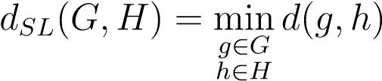 (10)

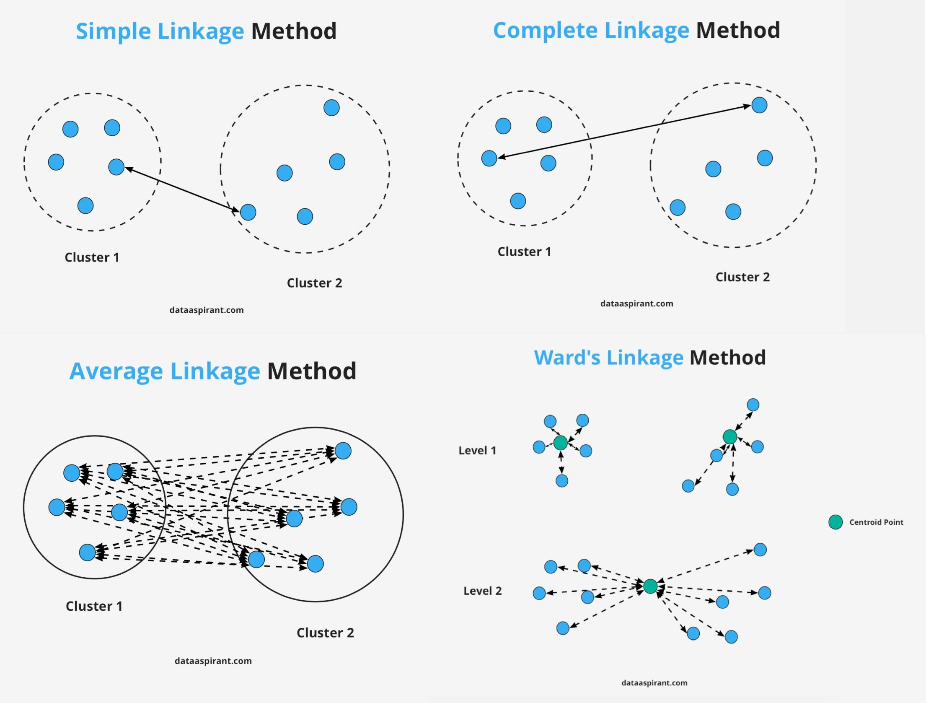

Figure 14: HAC clustering (Sultana, 2020)

The complete linkage (CL) is the opposite of single linkage: complete linkage is the maximum distance betweenany two objects, *g* ∈ *G* and *h* ∈ *H*:

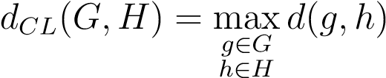 (11)

The avarage linkage (AL) is the average between groups:

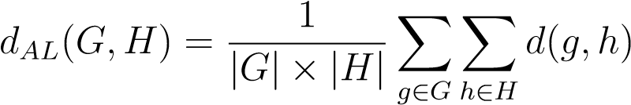 (12)

Finally, in the ward linkage (WL) an error function is specified for each cluster. This error function is the average distance between each data point in a cluster and the cluster’s center of gravity:

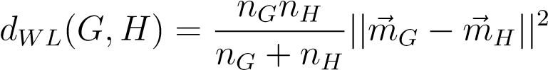 (13)

Where *m~j* is the center of cluster *j*, and *nj* is the number of points in it.

The one we choose to use is called Ward Linkage. In constrast the others, it evaluates cluster variance rather than calculating distance directly. Ward’s is said to be the most suitable method as it minimized sum of square error (SSE).

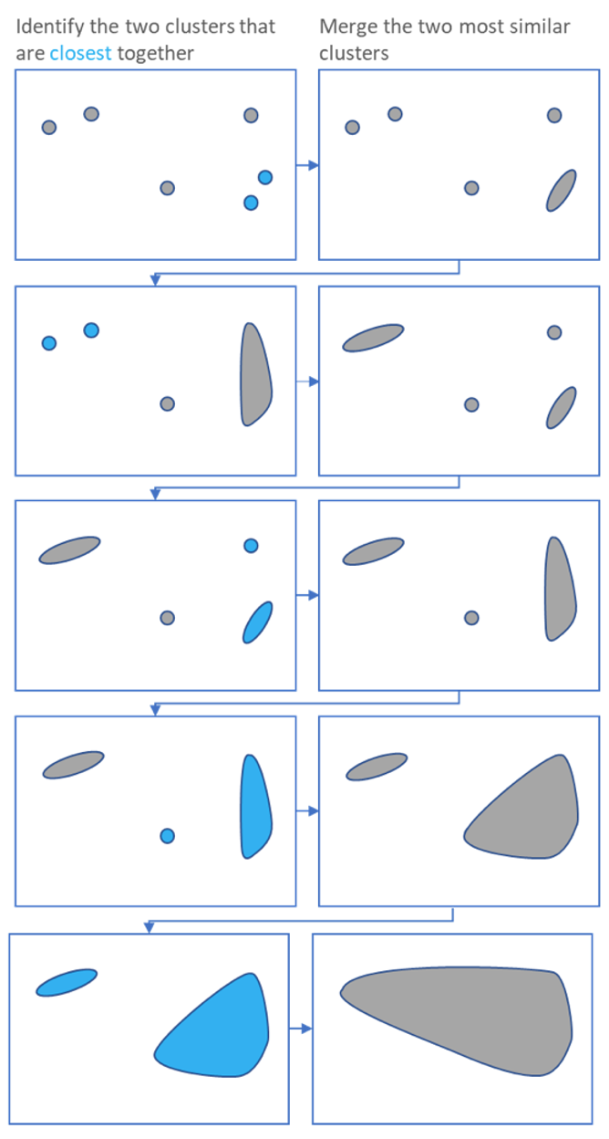

Figure 15: Ward Linkage (Ignacio Gonzalez et al., 2017)

### Other Methods

In 2014, Malinen et al. (2014) proposed a different method for K-means clustering, putting the data into a specified clustering model that is best for identical pathological data of same size and dimensions. Then apply an inverse transform from this pathological data back to the original data, while simultaneously improving the ideal clustering structure. K-means clustering is used to update the clustering model after each modification. If the changes are minor, the data vectors will eventually return to their original location without disrupting the clustering structure. The key items of this technique are determining an appropriate artificial data structure, performing the mapping, and controlling the inverse transformation illustrated in Figure 16. Alternatively, Fränti (2018) introduced using Random Swap algorithms which using prototype swaps to solve clustering, then using K-means to fine-tuning their positions. The basic idea is replacing the randomly picked centroid with the random data of the object and selecting centroids to replace by increasing minimum cost function.

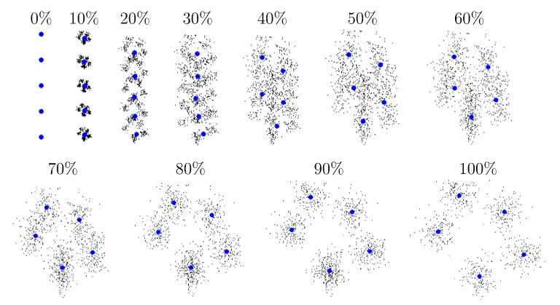

Figure 16: K-means* algorithm (Malinen et al., 2014)

As trajectories vary in lengths, shapes, and densities, many of clustering techniques are susceptible. C. Zhong et al. (2010) presented a graph-theoretical clustering method which is not impacted by those differences. In the beginning, two round minimal spanning trees are used to construct a graph and identify separate clusters that include clusters separated by distance and density divided by comparing the cuts in the two round minimal spanning trees.

*Density peaks* algorithm (Rodriguez & Laio, 2014) is another option. The algorithm initially computes the densities of all points, followed by the distances between them and the nearest point with a greater density (delta). Points with high delta and density value are chosen as cluster centers while the others joined another clusters with nearest greater density point. While popular, *O*(*N*2) time complexity has limited its application. Sieranoja & Fränti (2019) proposed new algorithm called FastDP illustrated in Figure 17 eliminating the quadratic time complexity constraint of density peaks and enables for the clustering of big datasets.

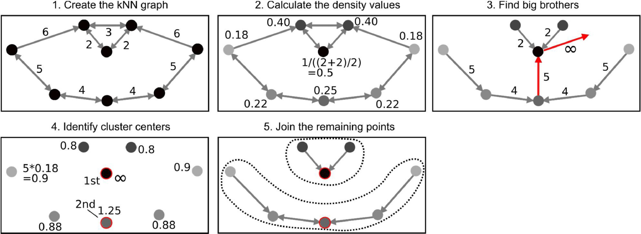

Figure 17: Fast density peaks algorithm (Sieranoja & Fränti, 2019)

Since GPS trajectories are spatial data, there are some clustering algorithms tailored for spatial data. Q. Zhao et al. (2015) utilizes a grid structure which example in Figure 18, takes into account a grid growth approach on the grid structure. This method combines the features of k-means with DBSCAN and does not require any inputs about the number of clusters. Rezaei & Franti (2018) provided other approach using grid-based for clustering. The approach initially segmented by splitting each dimension into a predetermined number of bins. In the second phase, initial clusters are generated by simply indexing each item and allocating it to a cell without computing distance. Each cell represent a single cluster. In the final phase, nearby cells are merged to form final clusters based on some criteria such as density or connectivity.

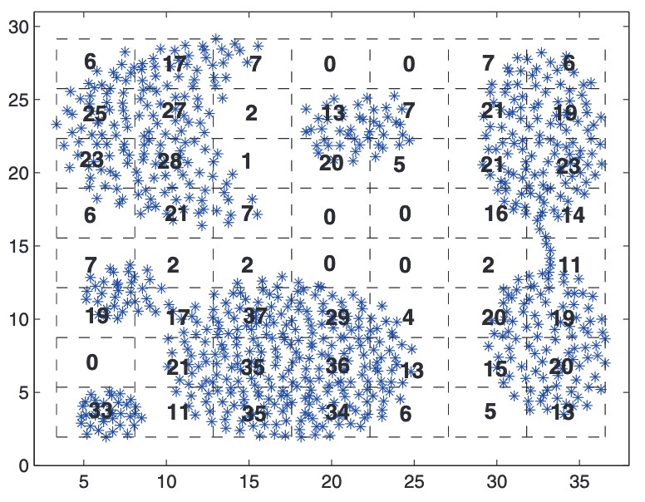

Figure 18: Grid Structure example (Q. Zhao et al., 2015)

## Quality Criteria

Comparing the results of two clustering methods on a data set is a difficult problem in cluster analysis. Different clustering methods with varying cost functions give different solutions, and no particular clustering approach is optimal for all available data sets. Thus, a main task is to determine the optimal clustering for a particular data set. However, the question of which cluster best represents the data set arises. Cluster validity indexes have been provided to handle this problem. They are categorized into internal and external indexes of which the former are validated without external info while the latter are validated against groundtruth.

Internal validity indexes evaluate the quality of a clustering method without external information. There are several instances of internal validity indexes based on cluster compactness and cluster separation. Internal validation methods may be used to determine the optimal clustering methodology and cluster number without requiring any extra information. A variety of internal clustering validation metrics for clustering have been studied by many authors. Table 1 shows 13 widely used internal validation indexes.

Table 1: Internal Validation Indexes

|  |  |  |
| --- | --- | --- |
| Name | Formula |  |
| SSW |  |  |
| SSB |  |  |
| Calinski-Harabasz (Caliński & Harabasz, 1974) |  |  |
| Ball&Hall (Ball & Hall, |  |  |
| Xu-index (L. Xu, 1997) | *Xu* = *D* log2 p*SSWM/*(*DN*2) | + log*M* |
| Krzanowski-Lai (Krzanowski & Lai, 1988) | *diffM* = (*M* − 1)2*/DSSWM*−1− |  |
| Hartigan (Hartigan, | or: *H* = log2 (*SSBM/SSWM*) |  |
| Dunn’s index | *d*(*ci,cj*) = min*x*∈*ci,x*0∈*cj* k*x* − *x*0k2 |  |
|  | diam(*ck*) = max*x,x*0∈*ck* k*x* − *x*0k2  Dunn =  diam(*ck*) | |
| Davies & Bouldin | where: *dij* = k*ci* − *cj*k2    and, *Ri* = max*j*=1*,...,M Rij,i* = 1*,...,M* | |
| Bayesian Information Criterion (BIC) |  | |
| Xie-Beni |  | |
|  |  | |

External validity indexes evaluate how closely the clustering match the ground truth (if available) or another clustering. Table 2 shows some investigated external validation measures. They are classified as pair-counting, information-theoretic, and set matching measures. Rand index, the Jaccard coefficient, the FowlkesMallows index are the pair-counting metrics. Clusters have also been compared using information theoretic indices such as entropy, Mutual Information, and variation of information. Mutual information evaluates the information shared between two clusters. F-measure and van Dongen criteria are set matching indices.

Some of the indices can be used to quickly identify the number of clusters by finding the minimum or maximum value, while others cannot. Q. Zhao et al. (2008) proposed an approach called knee point detection for BIC partitioning. The basic idea of this technique is run algorithm for several values of number of clusters, compare using some internal indices, then we will detect change in the Table 2: External Validation Indexes

|  |  |  |  |  |
| --- | --- | --- | --- | --- |
| Name | Formula | | |  |
| Entropy (Y. Zhao & Karypis, 2001) |  | | |  |
| Purity (Y. Zhao & Karypis, 2001) | *P* = P*i pi* (max*j pij/pi*) | | |  |
| F-measure (Van Rijsbergen, 1979) |  | | |  |
| Variation of Information (Meilă, 2003) | [ *i*(2 ) *j*(2 ) *ij*(2 )] | | *j* |  |
| Mutual Information (Banerjee et al., 2005) |  |  |  |  |
| Fowlkes and Mallows (Fowlkes & Mallows, 1983) |  |  |  |  |
| Minkowski score |  | |  |  |
| Goodman-Kruskal |  | |  |  |

curve which is called knee or jump point. However, because of some indices, SSW and log-likelihood are monotonous so there is no obvious knee point. Q. Zhao & Fränti (2014) used WB-Index, a sum-of-squares based index (Q. Zhao et al., 2009) to find the optimal number of clusters. When the proper number of clusters is acquired, this index will reach its minimal value.

WB-Index:

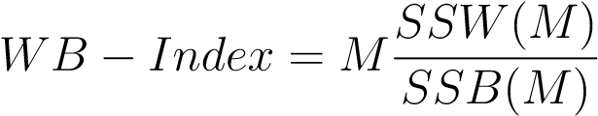 (14)

* SSW: Sum of squares within the clusters
* SSB: Sum of squares between the clusters

In this thesis, we will use Silhouette Coefficient as internal index and an external index introduced by Rezaei & Fränti (2016): Pair Sets Index.

### Silhouette Coefficient

The Silhouette Coefficient (Rousseeuw, 1987) measures an object’s similarity to its own cluster (cohesion) in comparison to other clusters (separation). The Silhouette Coefficient is defined for each sample and is composed of two scores:

* Cohension(a): The mean distance between a sample and all other points in the same class.
* Separation(b): The mean distance between a sample and all other points in the *next nearest cluster*.

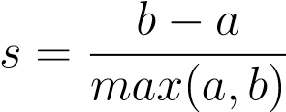 (15)

Silhouette coefficients varies between -1 and 1, as a high value indicate wellmatched and negative values indicate poorly match.

### Pair Sets Index

Set-matching measures comprise three questions:

1. How can the similarity of two clusters be measured?
2. How should the clusters be matched?
3. How is overall similarity measured?

Pair Sets Index (PSI) was introduced by (Rezaei & Fränti, 2016) includes optimum cluster pairing using Hungarian algorithm (Kuhn, 1955) as illustrated in Figure 19, a set matching measure based on Braun-Banquet (BB), and a chance correction.

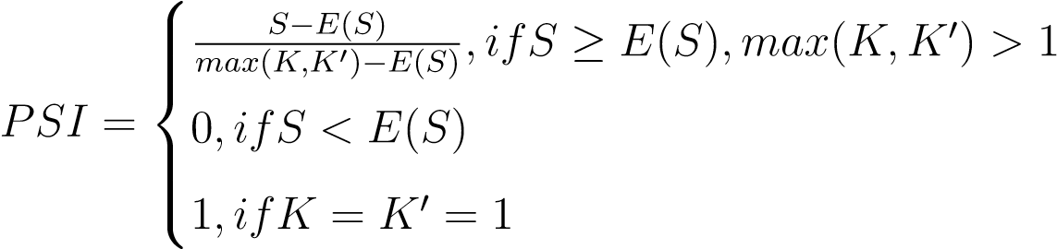 (16)

Where: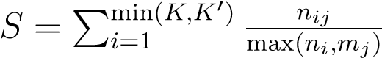 with *i,j*: paired clusters’ indexes

Pair Sets Index (PSI) simply is a metric that normalized in the range of [0, 1]. 1 indicates same number of clusters.

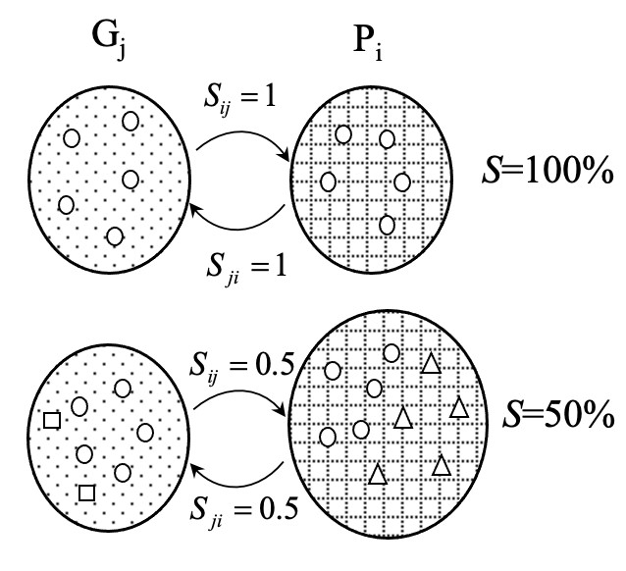

Figure 19: Pairing by Hungarian

# Experiments

In this section, we analyse and evaluate 5 distances DTW, LCSS, Hausdorff, Fréchet and HCSIM. Those distances were evaluated in two dataset: one is known data, one is unknown data then we used Silhouette to detect number of clusters. For the groundtruth dataset we used Pair Sets Index to evaluate. We used Python to implement all distances and *scipy* library for *hierarchical clustering analysis*.

## Ground Truth Data

### Data

The data we used are GPS data collected from Mopsi. MOPSI is a website that enables users in finding out where their friends are, as well as what is surrounding. This website provides photos sharing, navigation, and chatting with friends (Mariescu-Istodor, 2013). Users have recorded their trajectories. Detailed information about the routes, such as speed, distance traveled, and transportation mode used (walking, running, cycling, or skiing) is shown on the map, along with these trajectories by the method in Waga et al. (2012). Mopsi provides many approaches to find trajectories. Additionally, it offers suggestions and tools for data collecting management.

Mopsi data is classified into two types: geo-tagged images and trajectory data. Geo-tagged images include information about the location and time stamp. A trajectory is a collection of GPS points that are recorded at regular intervals. These trajectories are used as data in this thesis. There were 110 trajectories which were recorded by users in Joensuu, Finland grouped into 10 groups, with first group contains 20 trajectories and 10 for other groups, extracted from Mopsi data as shown in Figure 20. Green points are the start points and red points are the end points when users stop their routes. Figure 21 illustrated 10 trajectories groups defined by Mopsi users. Table 3 shows trajectory data structure.



Figure 20: Mopsi Trajectories



Figure 21: Mopsi Clusters Table 3: Mopsi Data structure

|  |  |  |  |
| --- | --- | --- | --- |
| Column | Type | Description | Example |
| Latitude | Double | Point latitude | 62.926880 (62° 55’ 36.7674") |
| Longitude | Double | Point longitude | 23.184691 (23° 11’ 4.8876") |
| Timestamp | String | Point timestamp | 1559983789 seconds |
| Altitude | Double | Point altitude | -1.0 meter |

### Trajectory Similarity

The quality of a clustering algorithm will depend on the metric used to measure similarity/dissimilarity between two trajectories. Figure 23 illustrated the process computed trajectory similarity.

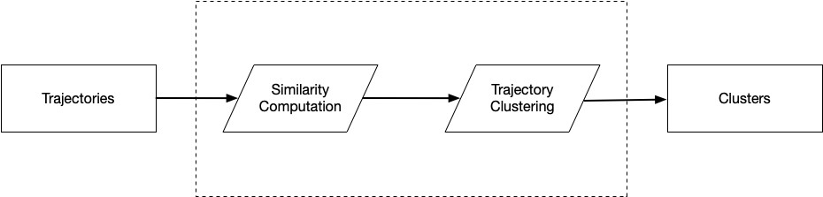

Figure 22: Overview of our process

Figure 22 shows our clustering process that consists of two components. We initially detected pointers among trajectories and then used them to calculate pair-wise distance/similarity between trajectories. With a set of trajectories with pair-wise similarity measures, we labeled trajectories based on the correlation between trajectory pairs. After that we used hierarchical clustering to obtain clusters of trajectories based on the label.

### Analysis of the distances

As mentioned before, we chose Ward Linkage method on HAC (Hierarchical Agglomerative Clustering) for the clustering. Below figures are Mopsi clustering results using 5 distances LCSS, DTW, Hausdorff, Fréchet and HCSIM with Ward Linkage cluster method. Due to groundtruth data, we used 10 as the number of clusters.



Figure 23: DTW Trajectories Clustering



Figure 24: LCSS Trajectories Clustering



Figure 25: Hausdorff Trajectories Clustering



Figure 26: Fréchet Trajectories Clustering



Figure 27: HCSIM Trajectories Clustering

### Clusters Validation

We used *Silhouette Score* to decided the number of clusters.

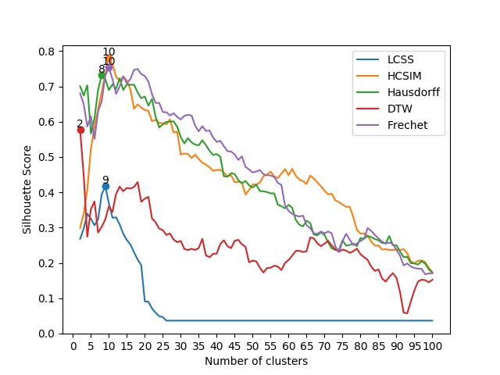

Figure 28: Silhouette Score depending on cluster

Figure 28 illustrated Silhouette Score based on number of clusters using 5 distances. 9 clusters are found with LCSS, 8 with Hausdorff and 10 with Frechet, HCSIM while DTW maximum at 2 clusters. HCSIM and Frechet give the best results as those equal with the groundtruth data.

Table 4: Mopsi Silhouette Scores

|  |  |  |  |  |  |
| --- | --- | --- | --- | --- | --- |
| Clusters | HCSIM | DTW | LCSS | Frechet | Hausdorff |
| 2 | 0.298768 | 0.576919 | 0.268120 | 0.680111 | 0.700506 |
| 3 | 0.340146 | 0.447950 | 0.297330 | 0.650049 | 0.674261 |
| 4 | 0.409051 | 0.274001 | 0.339466 | 0.586412 | 0.703117 |
| 5 | 0.523275 | 0.352317 | 0.324976 | 0.615615 | 0.566408 |
| 6 | 0.585378 | 0.374094 | 0.306599 | 0.550898 | 0.610376 |
| 7 | 0.635762 | 0.286120 | 0.323258 | 0.629292 | 0.689953 |
| 8 | 0.684482 | 0.302140 | 0.393962 | 0.657553 | 0.731702 |
| 9 | 0.735657 | 0.322905 | 0.417437 | 0.731107 | 0.720382 |
| 10 | 0.780062 | 0.360064 | 0.368766 | 0.753502 | 0.689732 |
| 11 | 0.762915 | 0.344460 | 0.328166 | 0.720096 | 0.705839 |
| 12 | 0.727740 | 0.395269 | 0.328786 | 0.678943 | 0.692692 |
| 13 | 0.715265 | 0.416145 | 0.309088 | 0.699268 | 0.722890 |
| 14 | 0.727732 | 0.402953 | 0.282231 | 0.728727 | 0.689695 |
| 15 | 0.716207 | 0.412412 | 0.264837 | 0.709048 | 0.705672 |
| 16 | 0.691088 | 0.410503 | 0.252075 | 0.721149 | 0.704394 |
| 17 | 0.637067 | 0.415109 | 0.230326 | 0.746946 | 0.704632 |
| 18 | 0.648691 | 0.429014 | 0.209700 | 0.749312 | 0.683025 |
| 19 | 0.640025 | 0.373099 | 0.193859 | 0.734810 | 0.666438 |
| 20 | 0.633123 | 0.382110 | 0.090747 | 0.729470 | 0.671273 |
| 21 | 0.630702 | 0.387021 | 0.089919 | 0.713444 | 0.645389 |
| 22 | 0.601537 | 0.325926 | 0.071233 | 0.678058 | 0.664584 |
| 23 | 0.605009 | 0.314910 | 0.058920 | 0.653062 | 0.613892 |
| 24 | 0.596298 | 0.297126 | 0.048962 | 0.653399 | 0.583749 |
| 25 | 0.595820 | 0.293018 | 0.046647 | 0.627256 | 0.592238 |
| 26 | 0.592593 | 0.279156 | 0.036524 | 0.626806 | 0.599689 |
| 27 | 0.606669 | 0.283243 | 0.036524 | 0.617713 | 0.600050 |
| 28 | 0.569360 | 0.266102 | 0.036524 | 0.624000 | 0.601084 |
| 29 | 0.571490 | 0.258856 | 0.036524 | 0.613484 | 0.585828 |

30 0.506735 0.262066 0.606522 0.556518

310.5096070.2393910.0365240.6165890.538377

320.5083620.2364890.0365240.6193210.553602

330.4970160.2401120.0365240.6176080.541344

340.5067220.2367170.0365240.5888460.535160

350.4942550.2422300.0365240.5727270.533088

360.4838440.2684240.0365240.5875280.547418

370.4785370.2214400.0365240.5738560.533254

380.4707920.2159360.0365240.5750940.517699

390.4606360.2258750.0365240.5551990.505916

400.4629030.2262920.0365240.5427070.508282

410.4640560.2535230.0365240.5459940.500828

420.4555420.2642380.0365240.5304990.445557

430.4453540.2474710.0365240.5163650.444546

440.4482610.2418700.0365240.5153660.454323

450.4291100.2627780.0365240.5075340.451549

460.4297270.2652520.0365240.4916000.434674

470.4276030.2527510.0365240.5018760.425555

480.3942850.2458090.0365240.4721770.432253

490.4060750.2015500.0365240.4647040.420008

500.4224840.2065190.0365240.4560970.413475

510.4214390.2044880.0365240.4588830.421552

520.4276370.1866260.0365240.4630390.403804

530.4456420.1727090.0365240.4511980.402914

540.4502960.1853950.0365240.4485400.400690

550.4585870.1863490.0365240.4477410.397080

560.4450610.1921190.0365240.4436420.396747

570.4399980.1894890.0365240.4270290.364683

580.4530320.1798460.0365240.4207620.360847

590.4657620.1998410.0365240.3629220.354533

600.4486200.2083220.0365240.3472720.364386

610.4665730.2206610.0365240.3391970.356293

620.4467090.2338850.0365240.3340480.322012

630.4359670.2346640.0365240.3315750.308222

640.4317300.2307220.0365240.3338470.303543 65 0.423495 0.232958 0.306664 0.319391

660.4474610.2719230.0365240.2985390.313171

670.4392510.2698000.0365240.2840060.280589

680.4277550.2554200.0365240.2822510.278021

690.4170010.2476070.0365240.2889250.286622

700.4047680.2546820.0365240.2833750.278888

710.3943070.2628510.0365240.2892910.257771

720.3958230.2488730.0365240.2835080.241314

730.3774120.2385700.0365240.2465510.236627

740.3726190.2316790.0365240.2305660.237244

750.3646790.2377970.0365240.2615440.264191

760.3587420.2346060.0365240.2823660.248876

770.3594160.2284350.0365240.2659590.250805

780.3299230.2331250.0365240.2507820.254994

790.2935410.2405070.0365240.2547850.247424

800.2831380.2245900.0365240.2619610.270319

810.2836230.2162560.0365240.2683220.268467

820.2766400.2082960.0365240.2988190.276532

830.2602650.1889660.0365240.2905520.272658

840.2489230.1772450.0365240.2794670.267682

850.2493520.1815670.0365240.2692990.263888

860.2377310.1561870.0365240.2603160.256741

870.2388930.1472270.0365240.2547170.255690

880.2367880.1603850.0365240.2579360.276045

890.2370530.1709210.0365240.2532300.250608

900.2375440.1579400.0365240.2371150.249617

910.2367190.1175850.0365240.2209390.232712

920.2389220.0592480.0365240.1929980.216464

930.2277430.0573350.0365240.1983600.217302

940.2041790.0903830.0365240.1898350.199266

950.1991480.1225960.0365240.1857110.198327

960.2059390.1470560.0365240.1838960.195421

970.2070490.1524790.0365240.1829560.205165

980.2021830.1509980.0365240.1676280.197993

990.1859750.1450770.0365240.1704540.181664 100 0.174085 0.152291 0.170831 0.171941

Additionally, we used Pair Sets Index to evaluate cluster results from those 5 distances. Figure 29 showed that HCSIM (shaped base distance) give the better cluster results than warping-based distances with Pair Sets Index is the highest with red color indicates the index is over 0.8 while blue indicates value below 0.8 and above 0.7, green indicates value is less than 0.7.

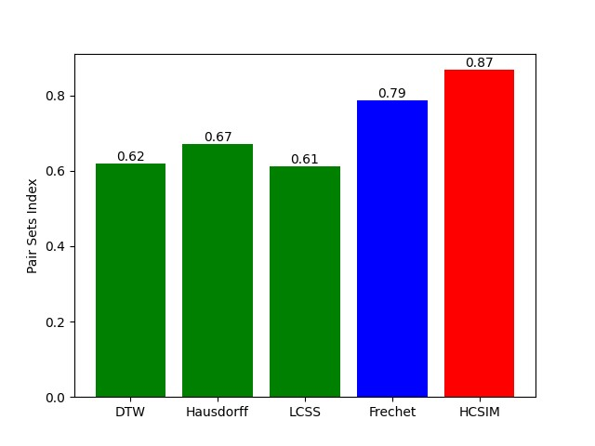

Figure 29: Pair Sets Index based on distance

Indeed, Figure 30 shows that HCSIM clusters nearly match ground truth data while other distances’ clusters are not good enough.

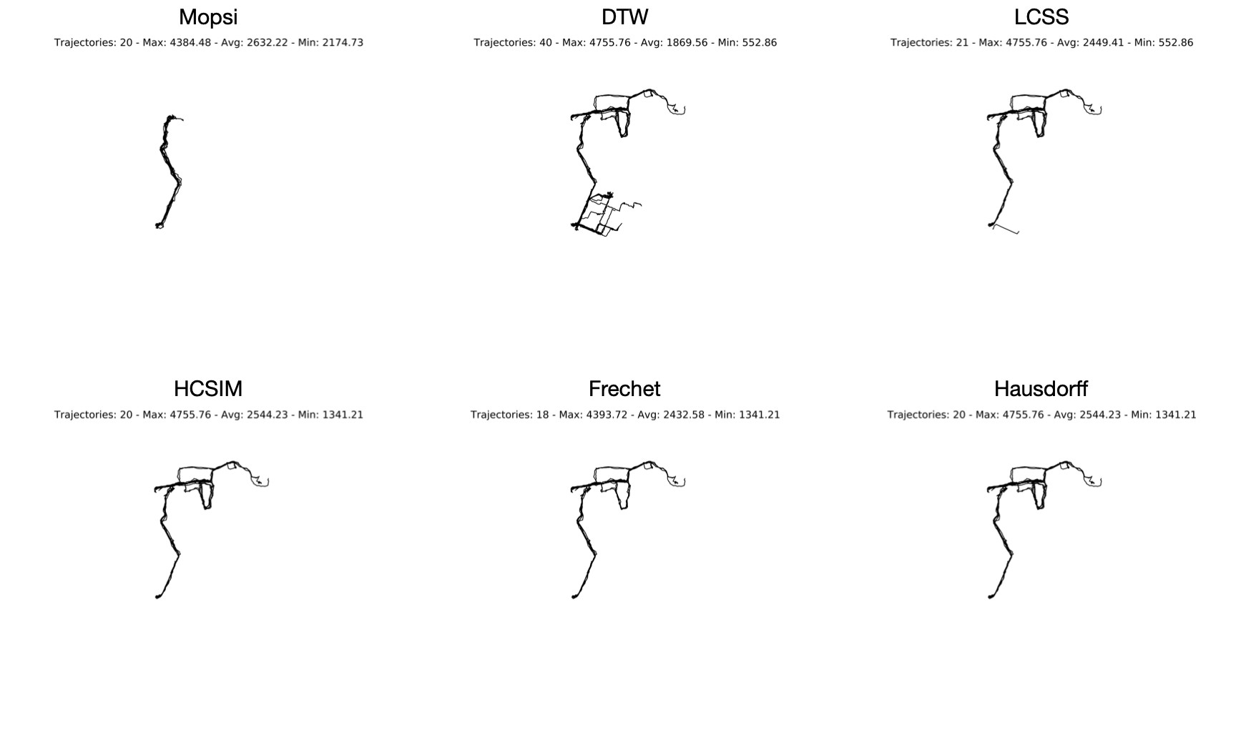

Figure 30: Trajectories Clusters 1

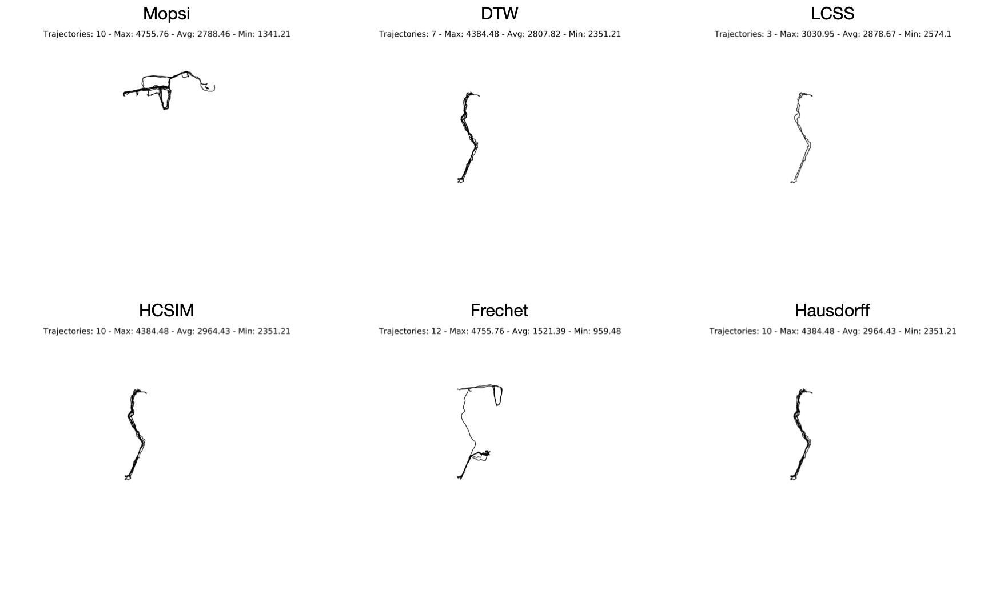

Figure 31: Trajectories Clusters 2

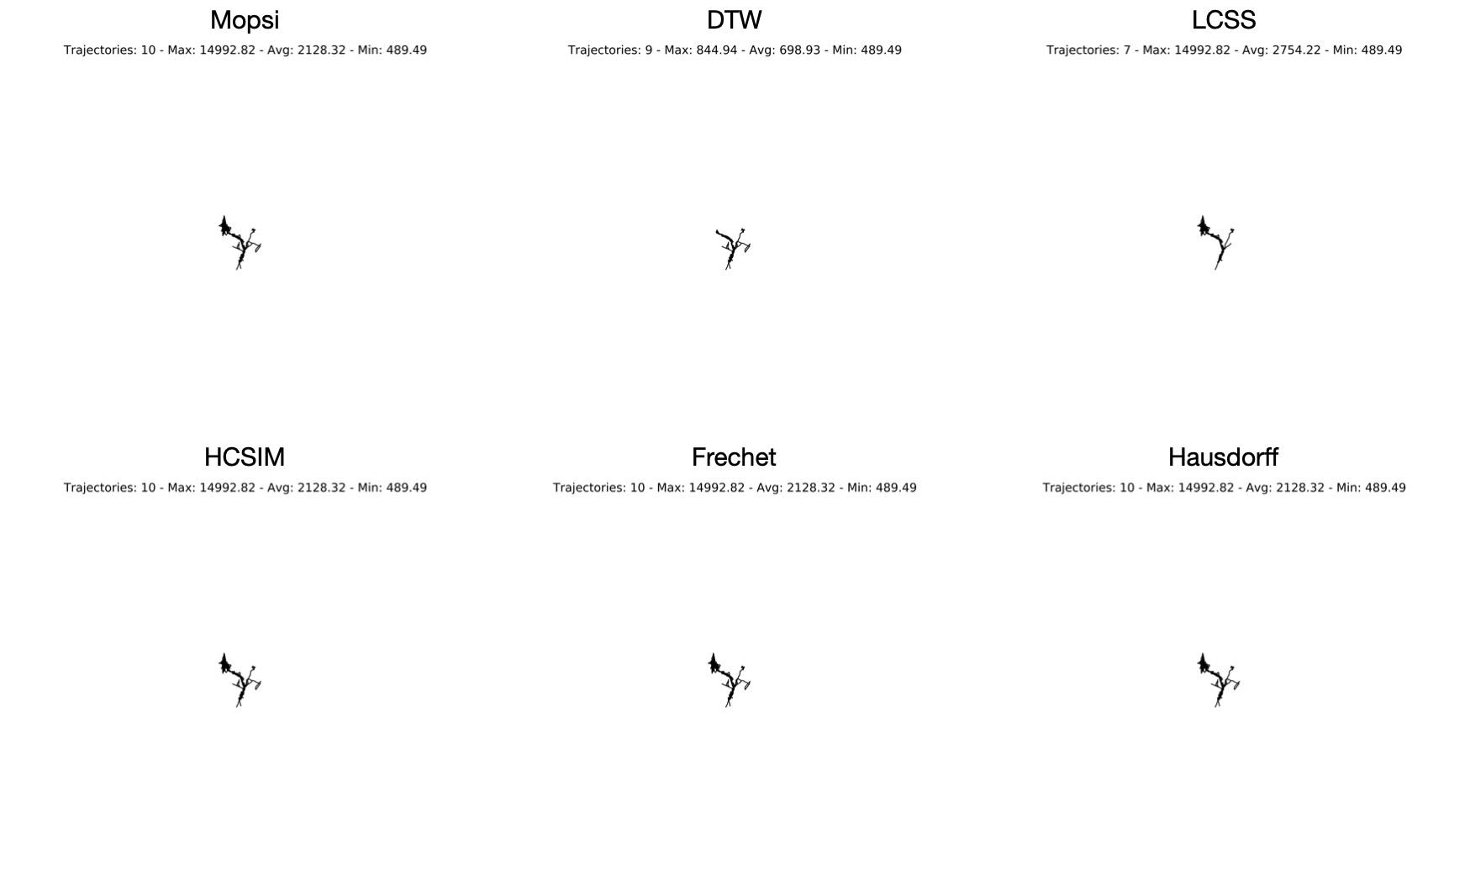

Figure 32: Trajectories Clusters 3

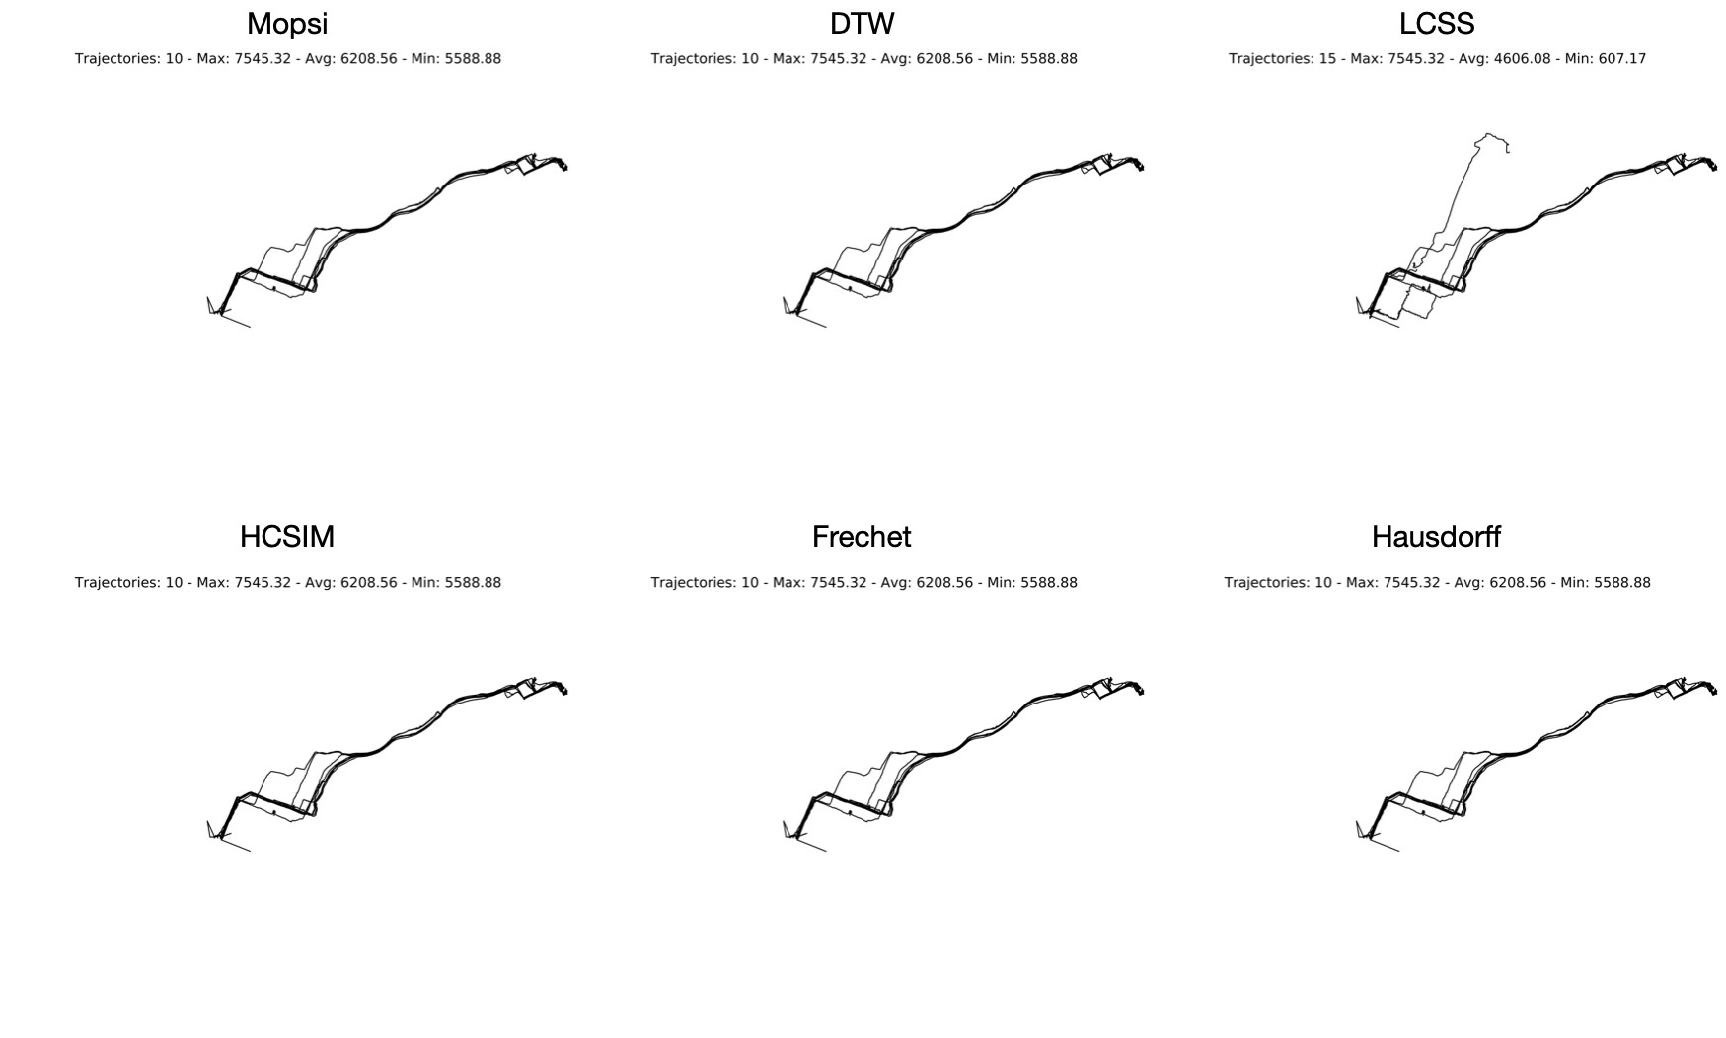

Figure 33: Trajectories Clusters 4

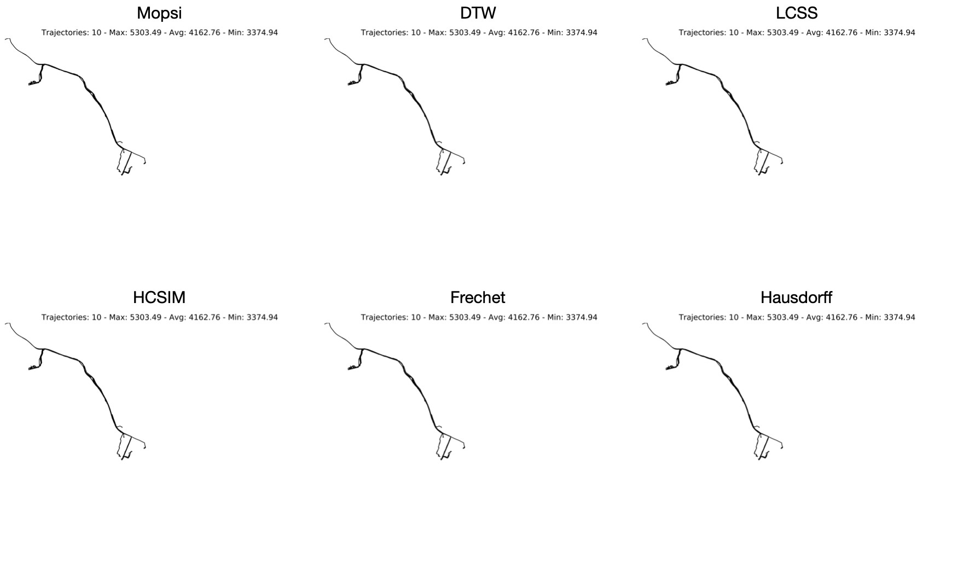

Figure 34: Trajectories Clusters 5

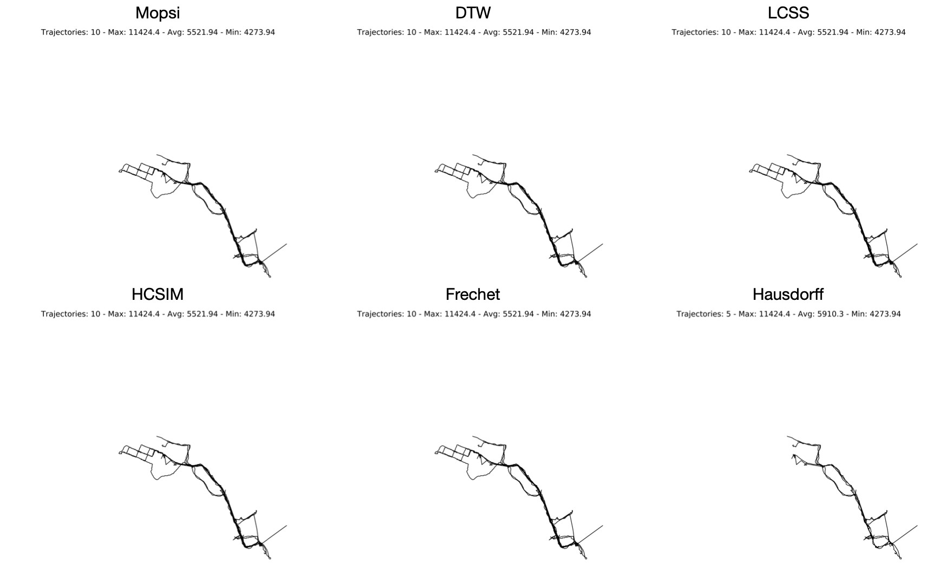

Figure 35: Trajectories Clusters 6

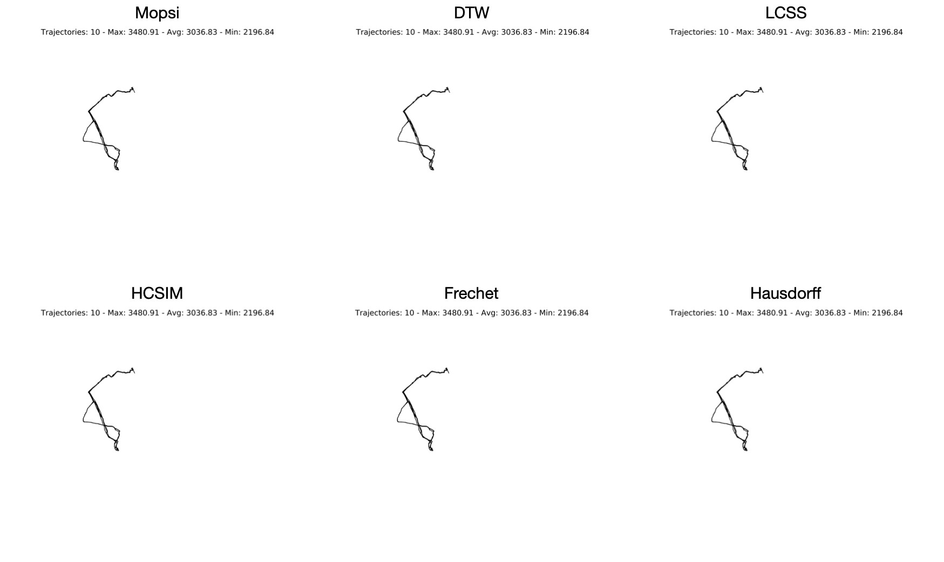

Figure 36: Trajectories Clusters 7

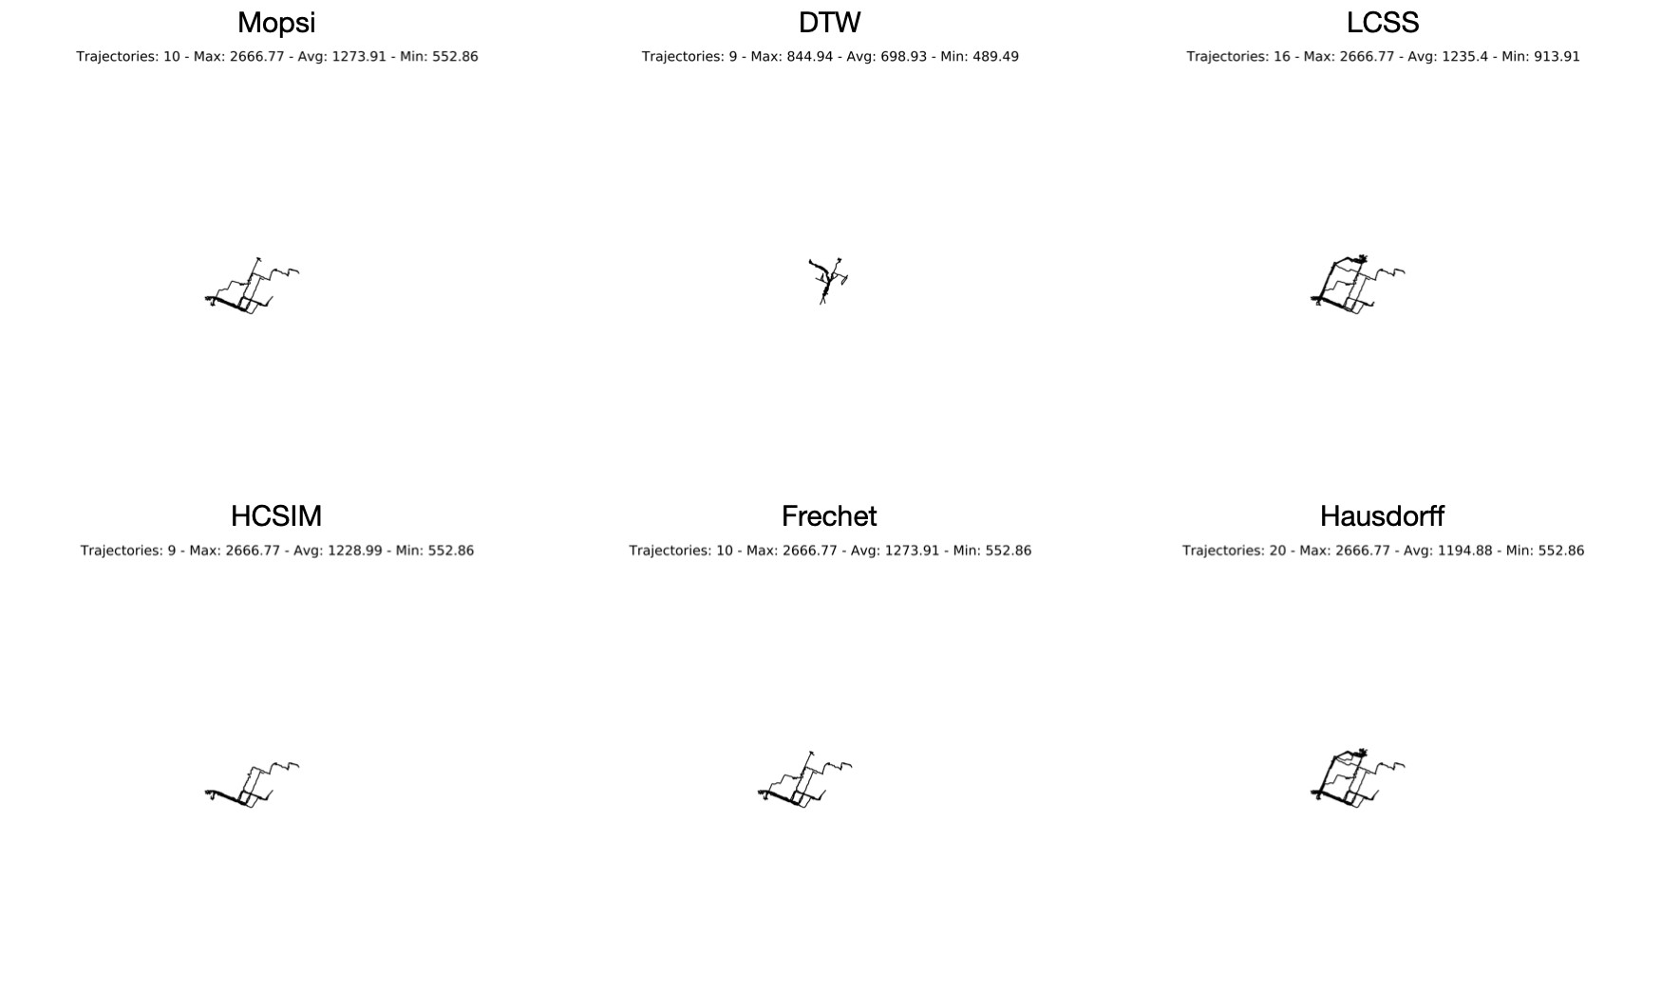

Figure 37: Trajectories Clusters 8

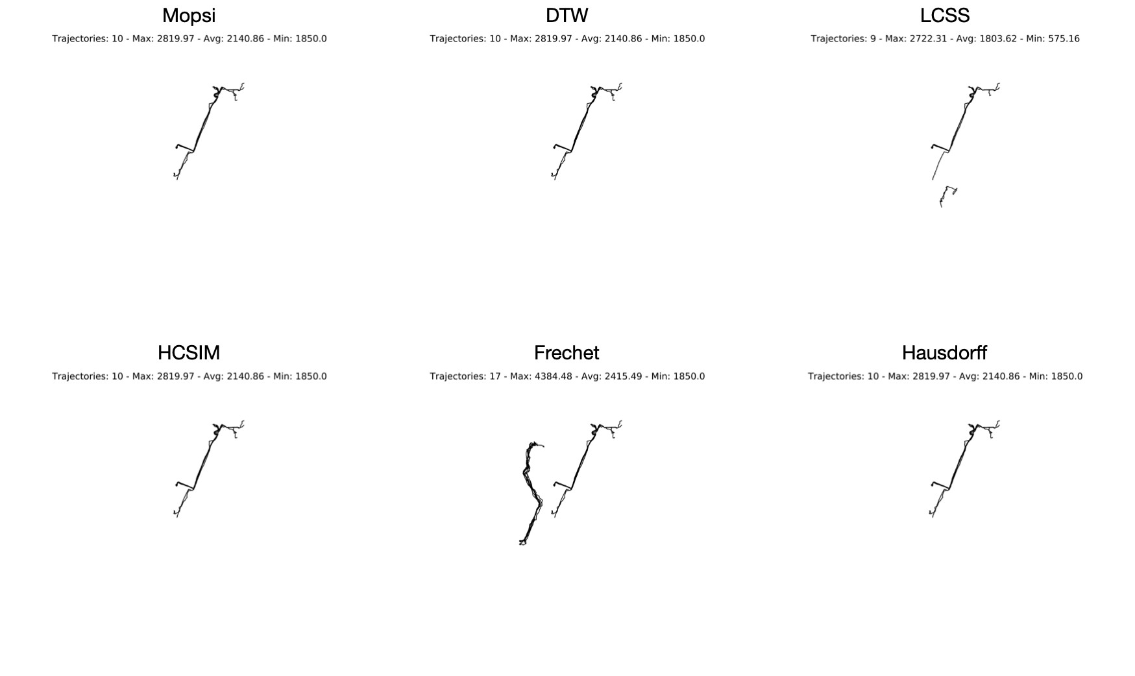

Figure 38: Trajectories Clusters 9

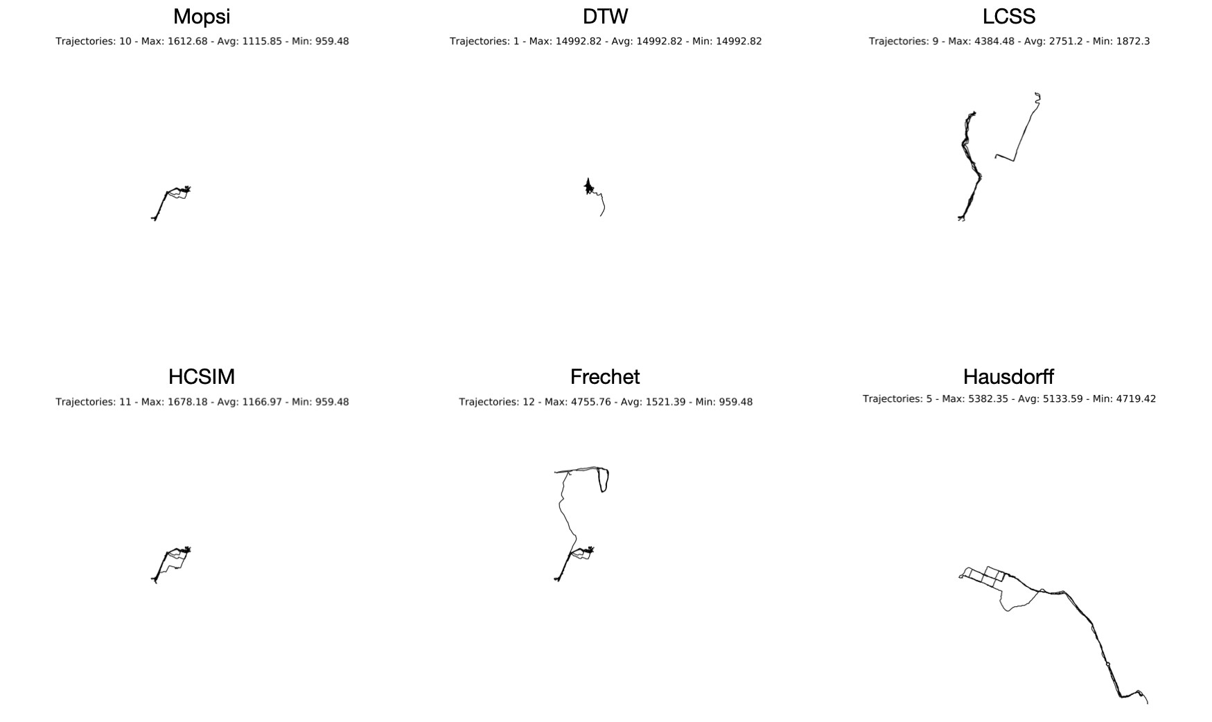

Figure 39: Trajectories Clusters 10

## Unknown Data

### Data

The data we used are GPS data from 536 San-Francisco taxis over a 24-day period. These data are public and can be found on Piorkowski et al. (2009). We extracted data as shown in Figure 40. We preprocessed data extracting 2574 trajectories with the same start point as black a point in Figure 31 at Caltrain station and red points indicate the end points which are drop-off locations.

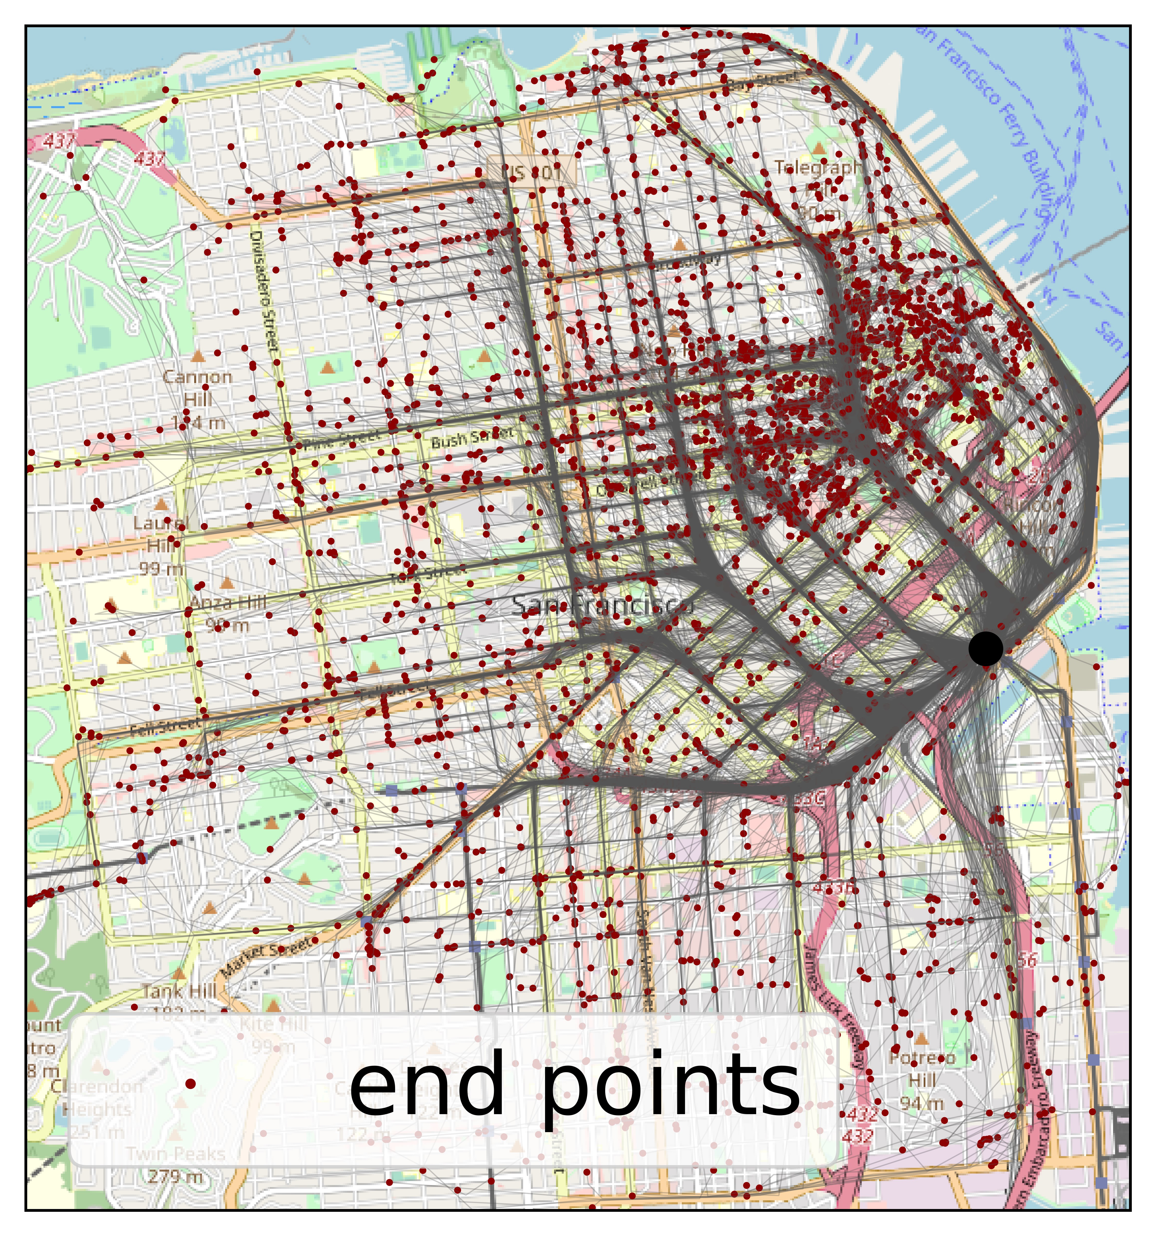

Figure 40: Caltrain Trajectories Dataset

### Analysis of the distances

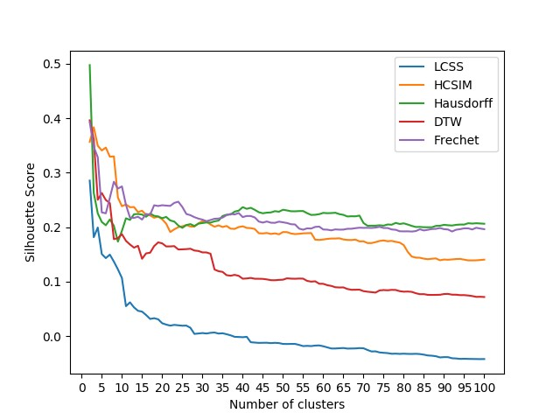

Figure 41: Silhouette Score

Figure 41 hardly determine optimal number of clusters as it ranges from 10 to 15 clusters. The shape-based distances (HC-SIM, Frechet, Hausdorff) are slightly better than warping-based distances (DTW, LCSS) as the Silhouette scores are higher. We chose 15 as the number of clusters for all distances then compare the results.

Table 5: Caltrain Silhouette Scores

|  |  |  |  |  |  |
| --- | --- | --- | --- | --- | --- |
| Clusters | HCSIM | DTW | LCSS | Frechet | Hausdorff |
| 2 | 0.356769 | 0.396301 | 0.285650 | 0.392788 | 0.497644 |
| 3 | 0.383545 | 0.361110 | 0.181747 | 0.347808 | 0.263201 |
| 4 | 0.349602 | 0.250431 | 0.199539 | 0.328405 | 0.225499 |
| 5 | 0.340964 | 0.262857 | 0.150745 | 0.227275 | 0.209657 |
| 6 | 0.346317 | 0.250004 | 0.143371 | 0.225573 | 0.203689 |
| 7 | 0.329542 | 0.244371 | 0.149779 | 0.254266 | 0.214275 |
| 8 | 0.330136 | 0.178117 | 0.136986 | 0.283555 | 0.202706 |

1. 0.254469 0.180204 0.122737 0.270990 0.173631
2. 0.238627 0.187296 0.106858 0.275026 0.193501
3. 0.241977 0.175068 0.055147 0.241094 0.216469
4. 0.236761 0.168340 0.062208 0.217643 0.213491
5. 0.237156 0.162590 0.052939 0.217235 0.223876
6. 0.227760 0.165999 0.046684 0.219286 0.224394

150.2304000.1421600.0451900.2141710.223323

160.2226280.1521190.0389730.2244740.219284

170.2218450.1532640.0317900.2229940.225172

180.2174800.1654210.0330720.2403600.221023

190.2195360.1722520.0310800.2390410.219824

200.2145890.1704620.0238660.2404470.216707

210.2065160.1648100.0213840.2397940.218972

220.1912560.1649060.0194650.2392000.212498

230.1962100.1653790.0208490.2447600.210494

240.2002000.1592680.0200660.2468770.203208

250.2018130.1595070.0192650.2372520.198961

260.2041810.1598890.0195300.2243760.204022

270.2013730.1606090.0155870.2221800.205813

280.2011140.1573320.0042930.2185550.202371

290.2071400.1564690.0050480.2158850.206669

300.2111010.1538770.0058160.2140250.207684

310.2101750.1538210.0050070.2111670.208809

320.2050370.1514340.0062370.2133110.208455

330.2010240.1224370.0068210.2156030.210904

340.2034830.1193290.0048950.2160180.212265

350.2004730.1180810.0054630.2177620.220704

360.2023840.1120600.0036770.2222470.223063

370.1973900.1110810.0016230.2245560.223387

380.1970100.112646-0.0010830.2234890.228722

390.2003550.110885-0.0013660.2261410.230493

400.2018050.105598-0.0018200.2187080.236885

410.1988260.106026-0.0010560.2207350.233837

420.1984030.106980-0.0110150.2206280.235701

430.1968070.105476-0.0115980.2180040.231970 44 0.189037 0.105457 -0.012231 0.210478 0.227581

1. 0.188693 0.105263 -0.012043 0.208605 0.225654
2. 0.189510 0.104289 -0.011958 0.210598 0.226802
3. 0.187696 0.102868 -0.012662 0.208361 0.227238
4. 0.188798 0.102793 -0.012089 0.208134 0.229546
5. 0.187074 0.103403 -0.012561 0.210294 0.228537

500.1912320.103788-0.0141110.2091170.232126

510.1910610.106281-0.0142810.2078110.230924

520.1885510.105691-0.0141130.2055730.229375

530.1874680.105492-0.0141150.2051490.229310

540.1879840.105837-0.0158970.1975930.229700

550.1888220.105679-0.0181040.1955430.229799

560.1891360.101598-0.0176710.1979640.225874

570.1893780.100226-0.0180830.1976670.222617

580.1772760.100837-0.0171390.2006590.222915

590.1767380.096370-0.0168700.2011890.224060

600.1775560.096224-0.0183980.1959210.226399

610.1786550.093656-0.0204410.1956270.225817

620.1793290.092366-0.0224980.1943520.226085

630.1793180.089905-0.0225140.1960770.226631

640.1797840.089470-0.0220620.1956260.224136

650.1776710.089635-0.0216170.1957100.222778

660.1767590.086727-0.0226800.1971780.219825

670.1765860.085264-0.0225280.1972770.220204

680.1773660.085366-0.0224000.1983240.220077

690.1740870.085466-0.0217880.1991880.221409

700.1742910.082765-0.0221040.1988790.207809

710.1709720.081721-0.0252390.1990530.202763

720.1709950.080905-0.0279620.1987810.202938

730.1727490.080132-0.0277510.1994510.202961

740.1748670.084109-0.0297480.2008300.203637

750.1758500.084758-0.0304060.1986800.202993

760.1743530.084321-0.0309730.1986160.205167

770.1749530.085100-0.0322150.1960210.204680

780.1732490.084901-0.0319740.1953570.208015 79 0.171855 0.082722 -0.032416 0.192647 0.206051

1. 0.167248 0.081761 -0.032063 0.192481 0.207178
2. 0.154736 0.082040 -0.032430 0.192582 0.205017
3. 0.146156 0.081407 -0.032513 0.192138 0.202493
4. 0.144325 0.078929 -0.032250 0.193020 0.200483
5. 0.144089 0.077166 -0.032722 0.196295 0.200646

850.1423280.077269-0.0338280.1941510.200086

860.1413680.075914-0.0353150.1953980.200021

870.1422700.075813-0.0357650.1967800.200021

880.1427860.075910-0.0367180.1971300.202505

890.1393980.076090-0.0388860.1985870.202735

900.1407990.077447-0.0383300.1965520.204501

910.1403960.077685-0.0383760.1958790.203706

920.1409740.076298-0.0404120.1922090.203204

930.1416980.076249-0.0408120.1954620.204461

940.1419200.075422-0.0415720.1965380.205025

950.1405900.075472-0.0413680.1980240.204963

960.1392280.074794-0.0415930.1980720.207391

970.1391990.073772-0.0417510.1959560.206780

980.1393470.072257-0.0418650.1990660.207357

990.1399090.072388-0.0419770.1976600.206953

1000.1406070.072018-0.0418860.1964790.206427

Figure 42 illustrates visual results for all distances with 15 clusters. Based on Mopsi experiment, HCSIM is expected to be the best. We observe that trajectories are well classified by HCSIM according to their paths in 47. The clusters using HCSIM seem to be consistent as the trajectories in each cluster grouped better than other distances. For example, the DTW cluster 5 in Figure 43, the LCSS cluster 8 in Figure 44, the Hausdorff cluster 3 in Figure 45, and the Frechet cluster 9 in Figure 46 got a lot of noise.

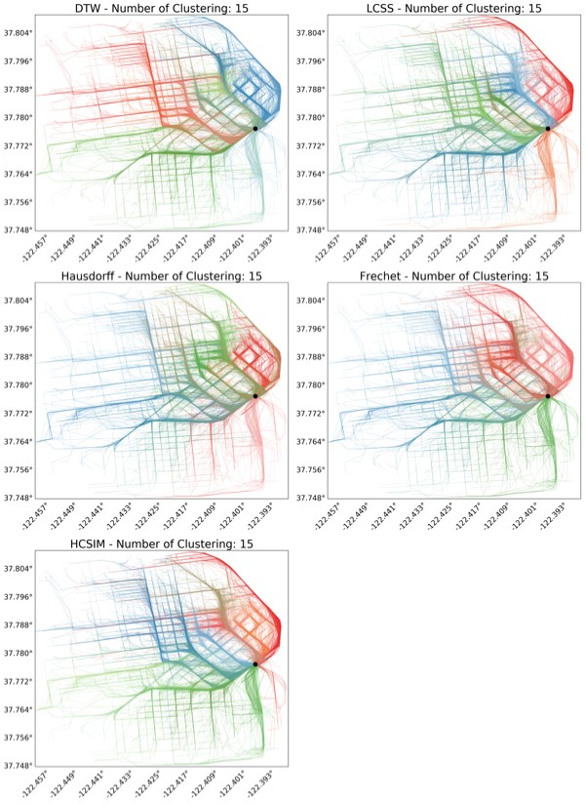

Figure 42: Caltrain Clusters

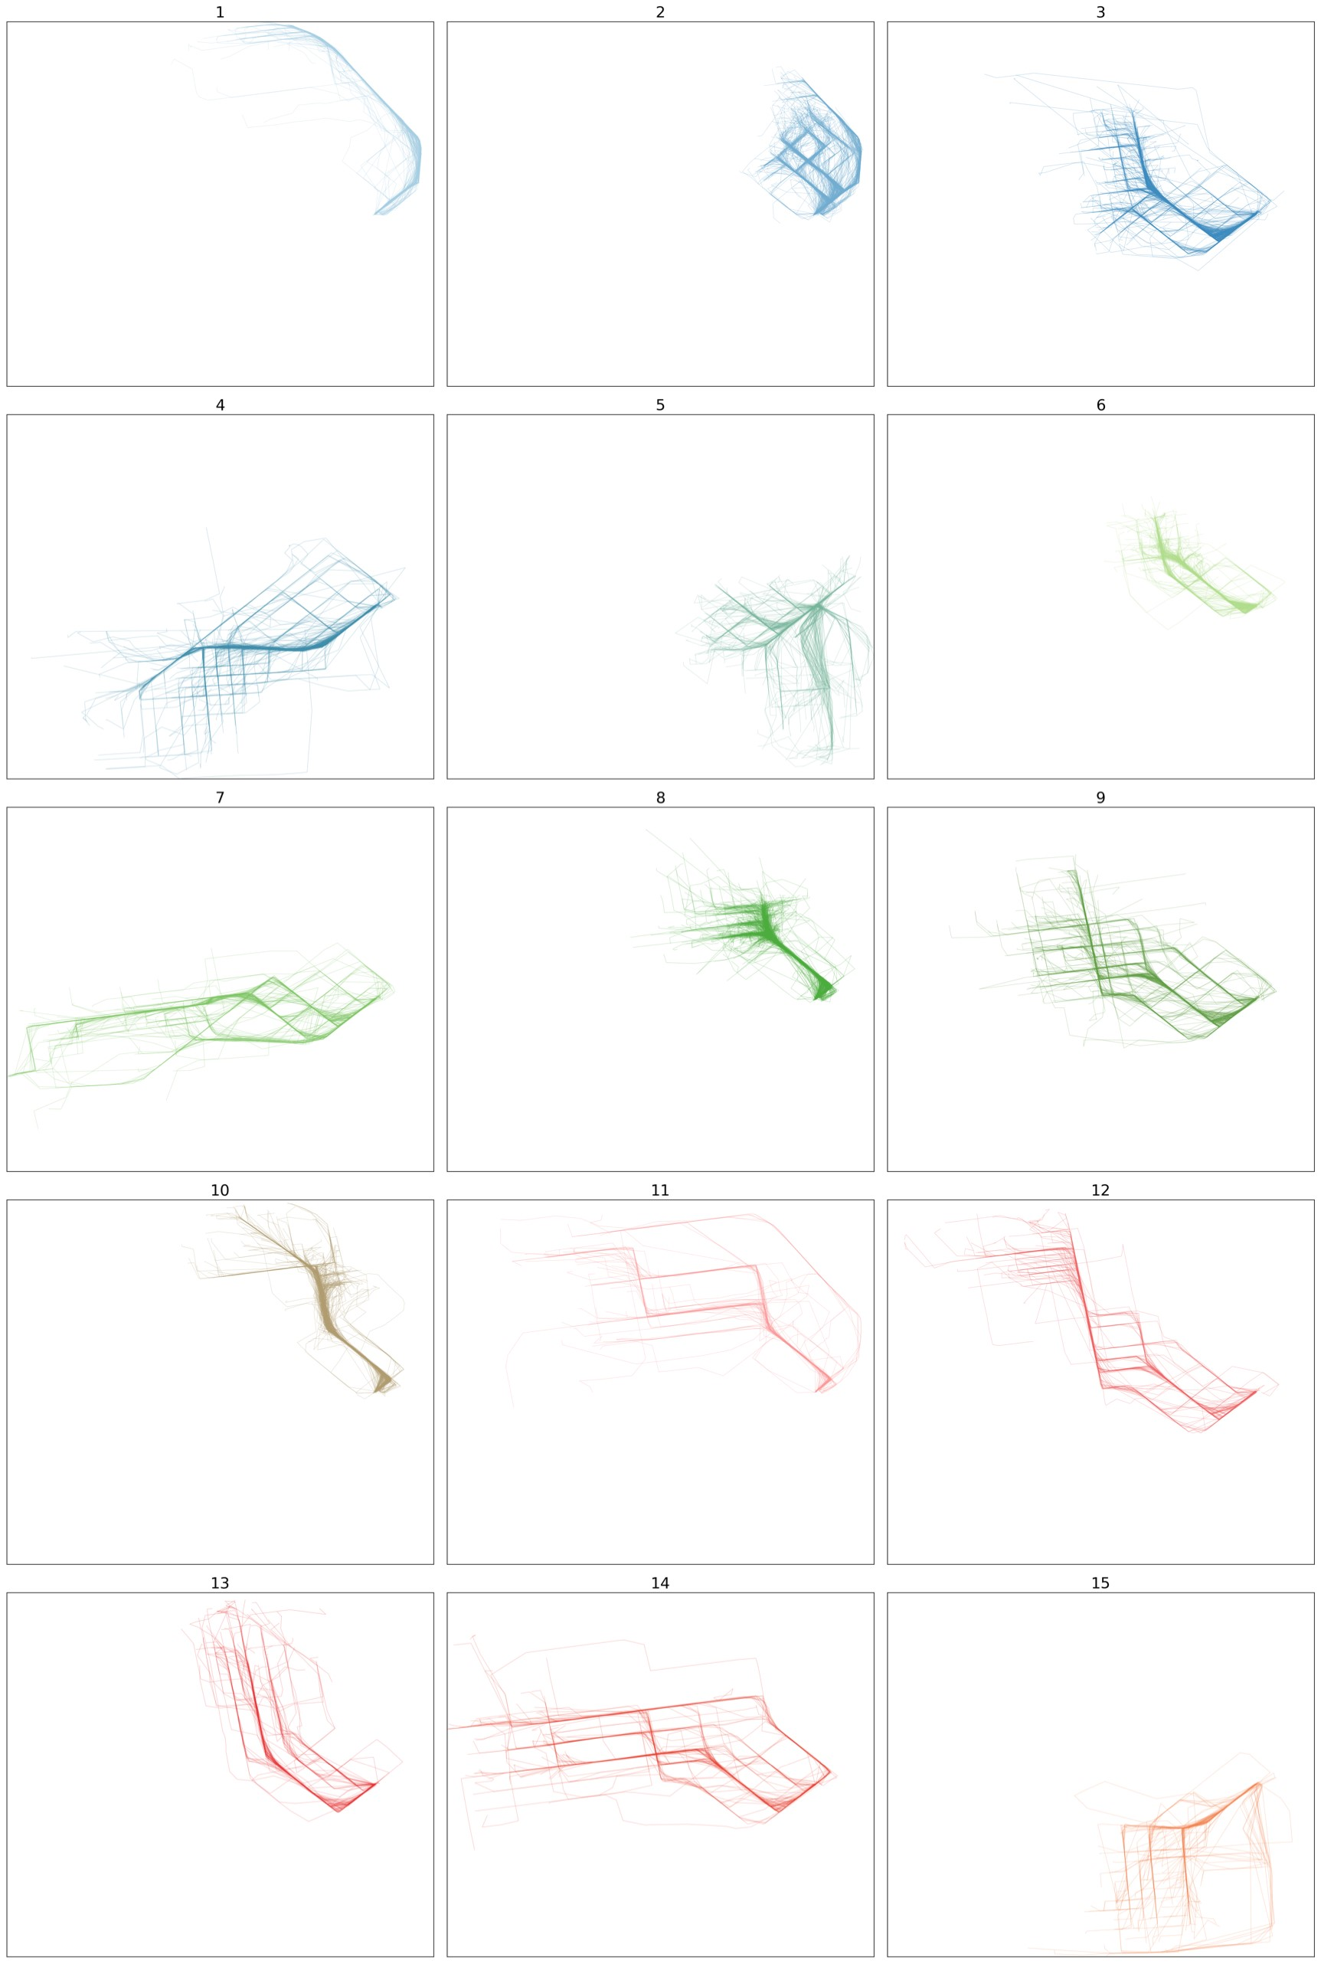

Figure 43: Caltrain DTW Clusters

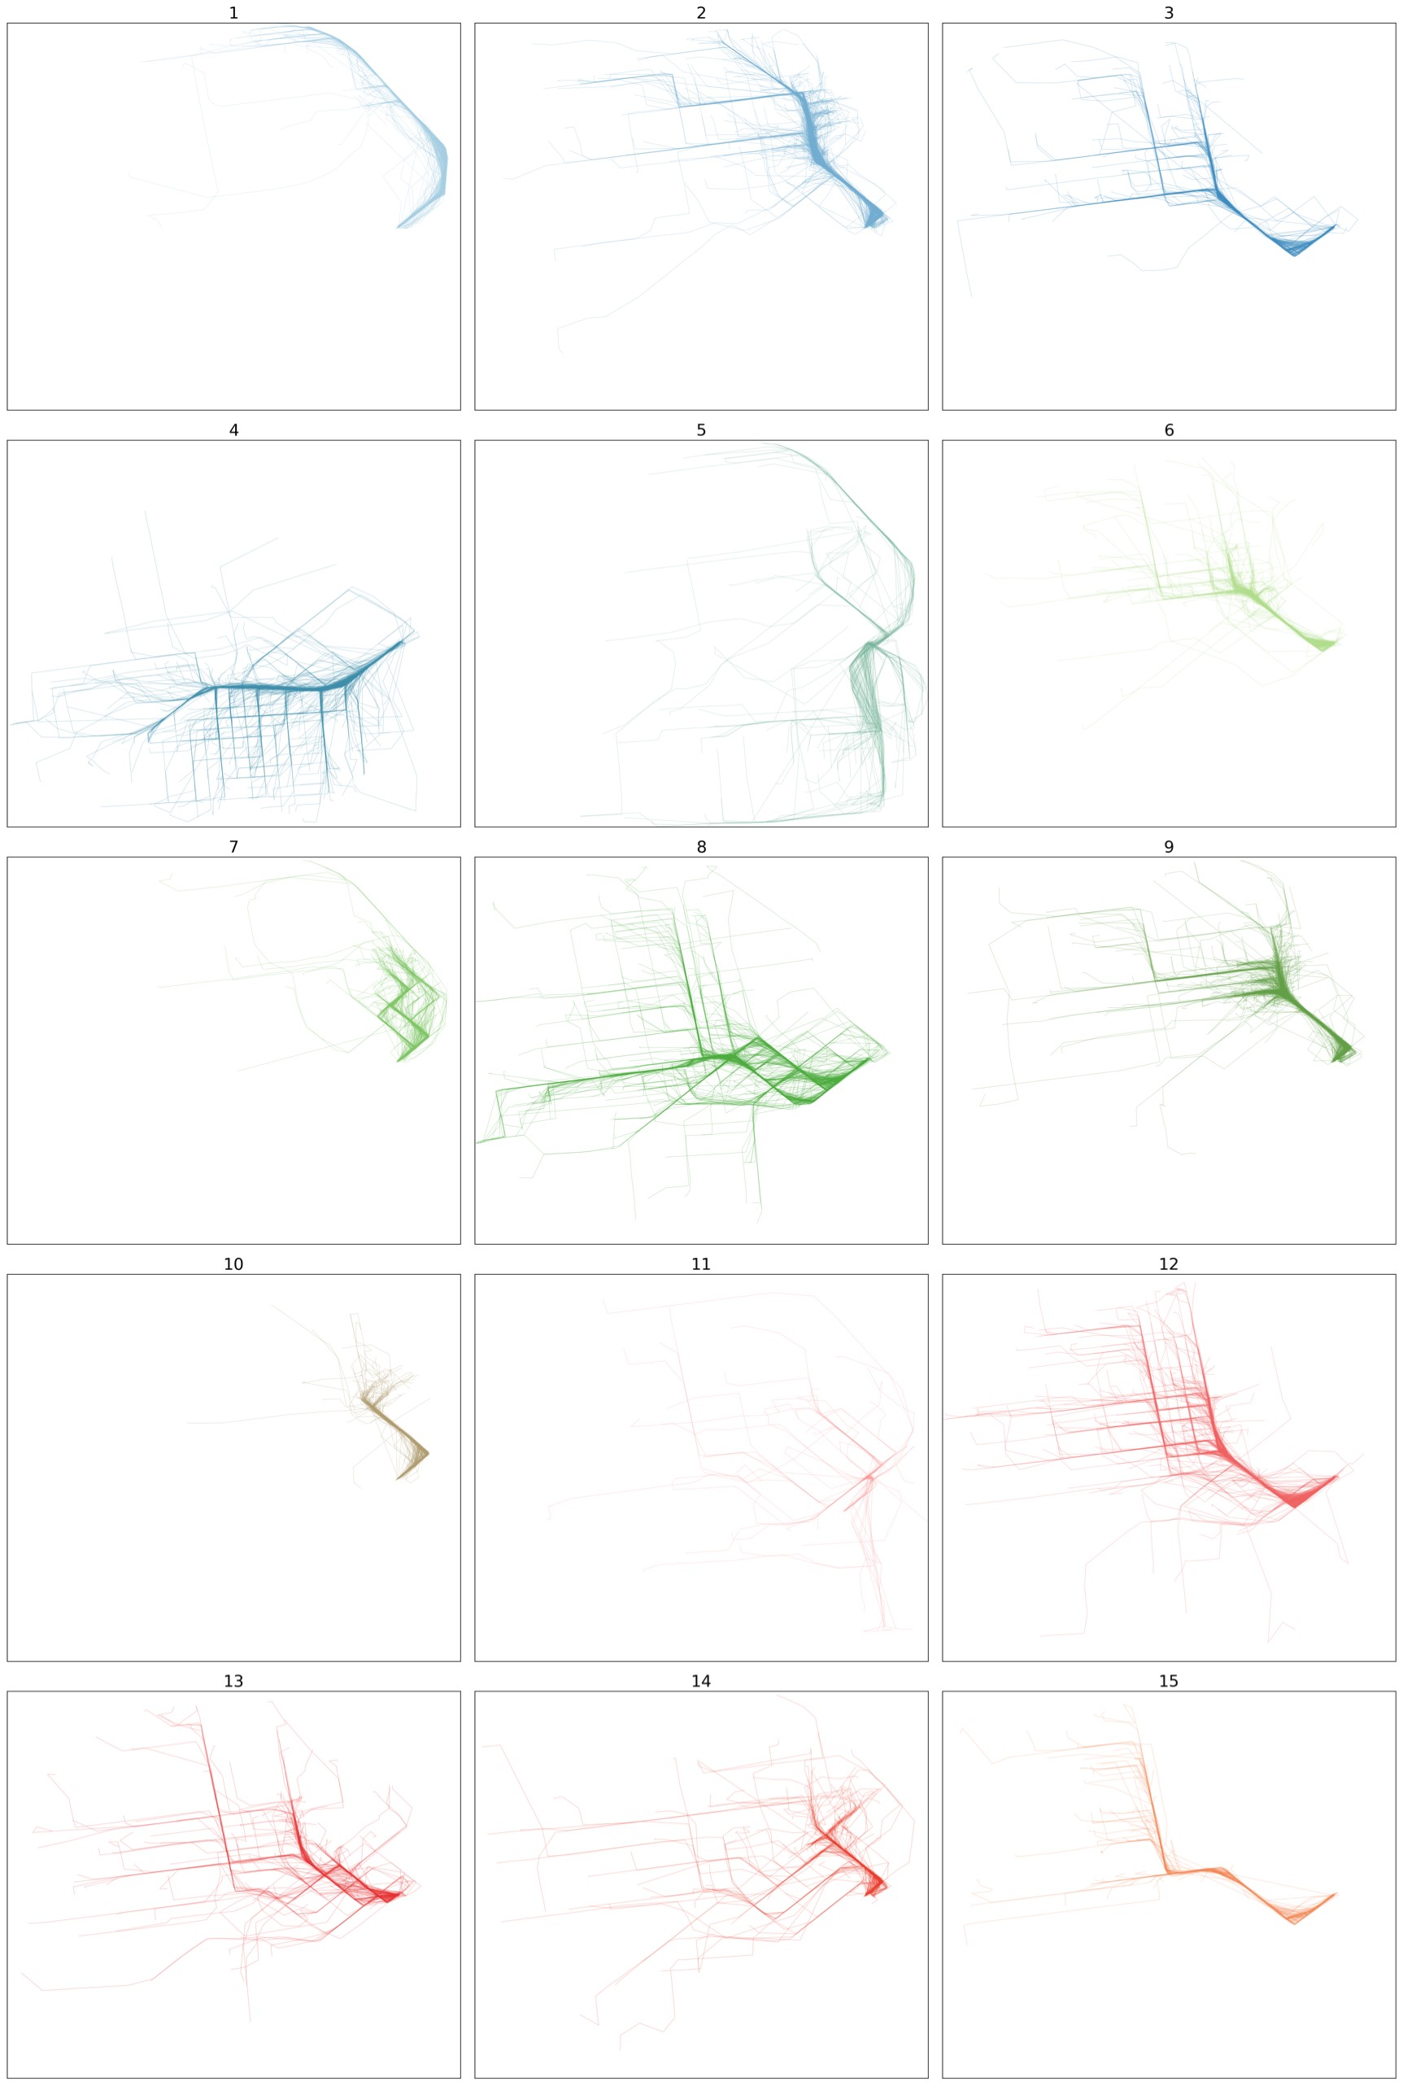

Figure 44: Caltrain LCSS Clusters

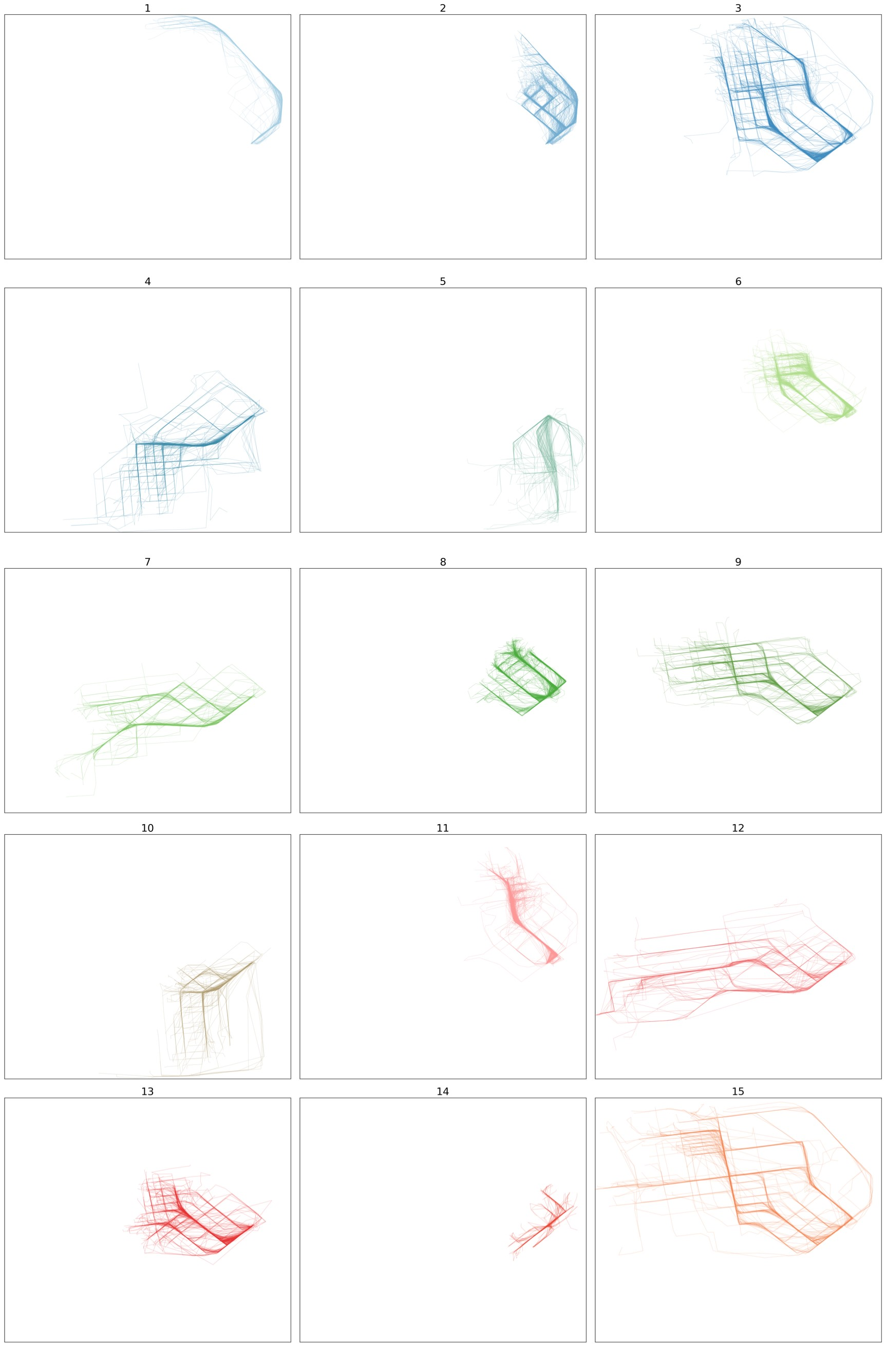

Figure 45: Caltrain Hausdorff Clusters

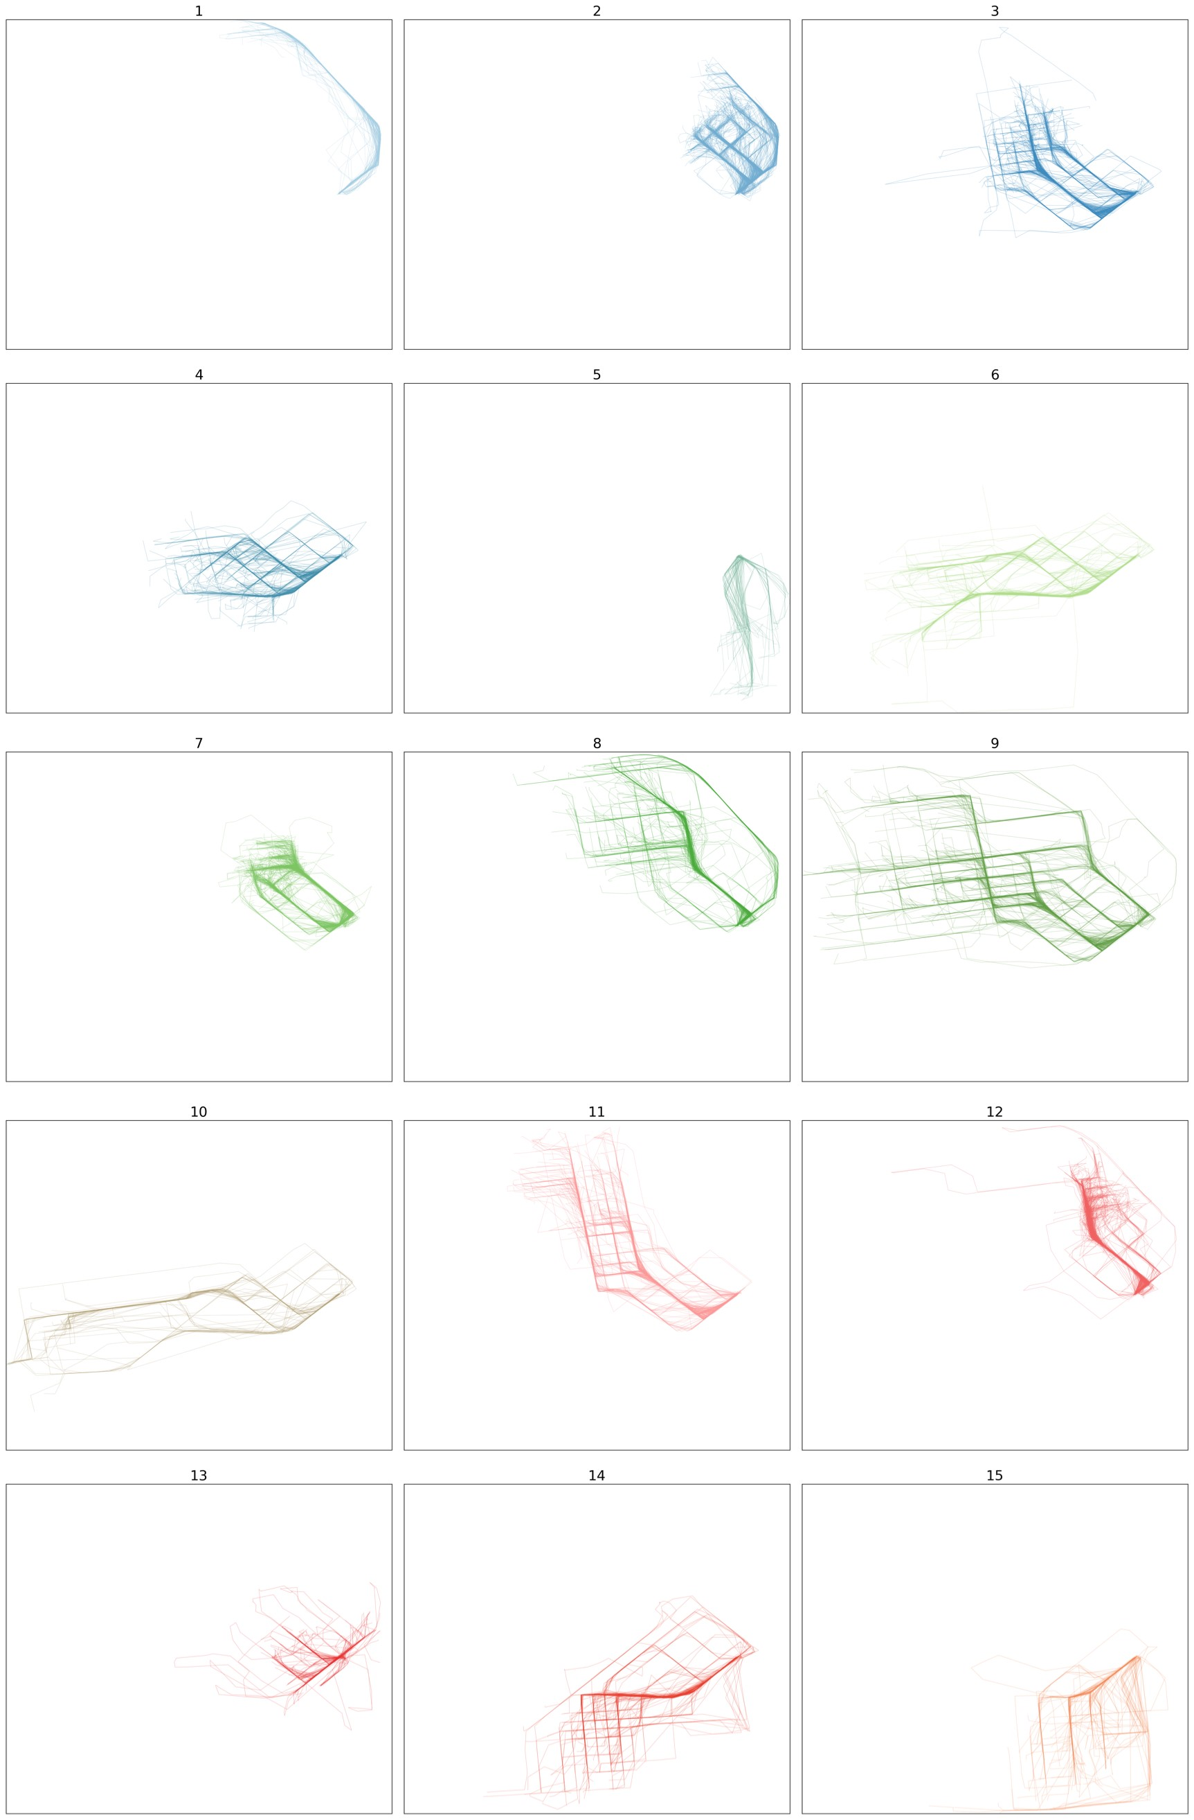

Figure 46: Caltrain Frechet Clusters

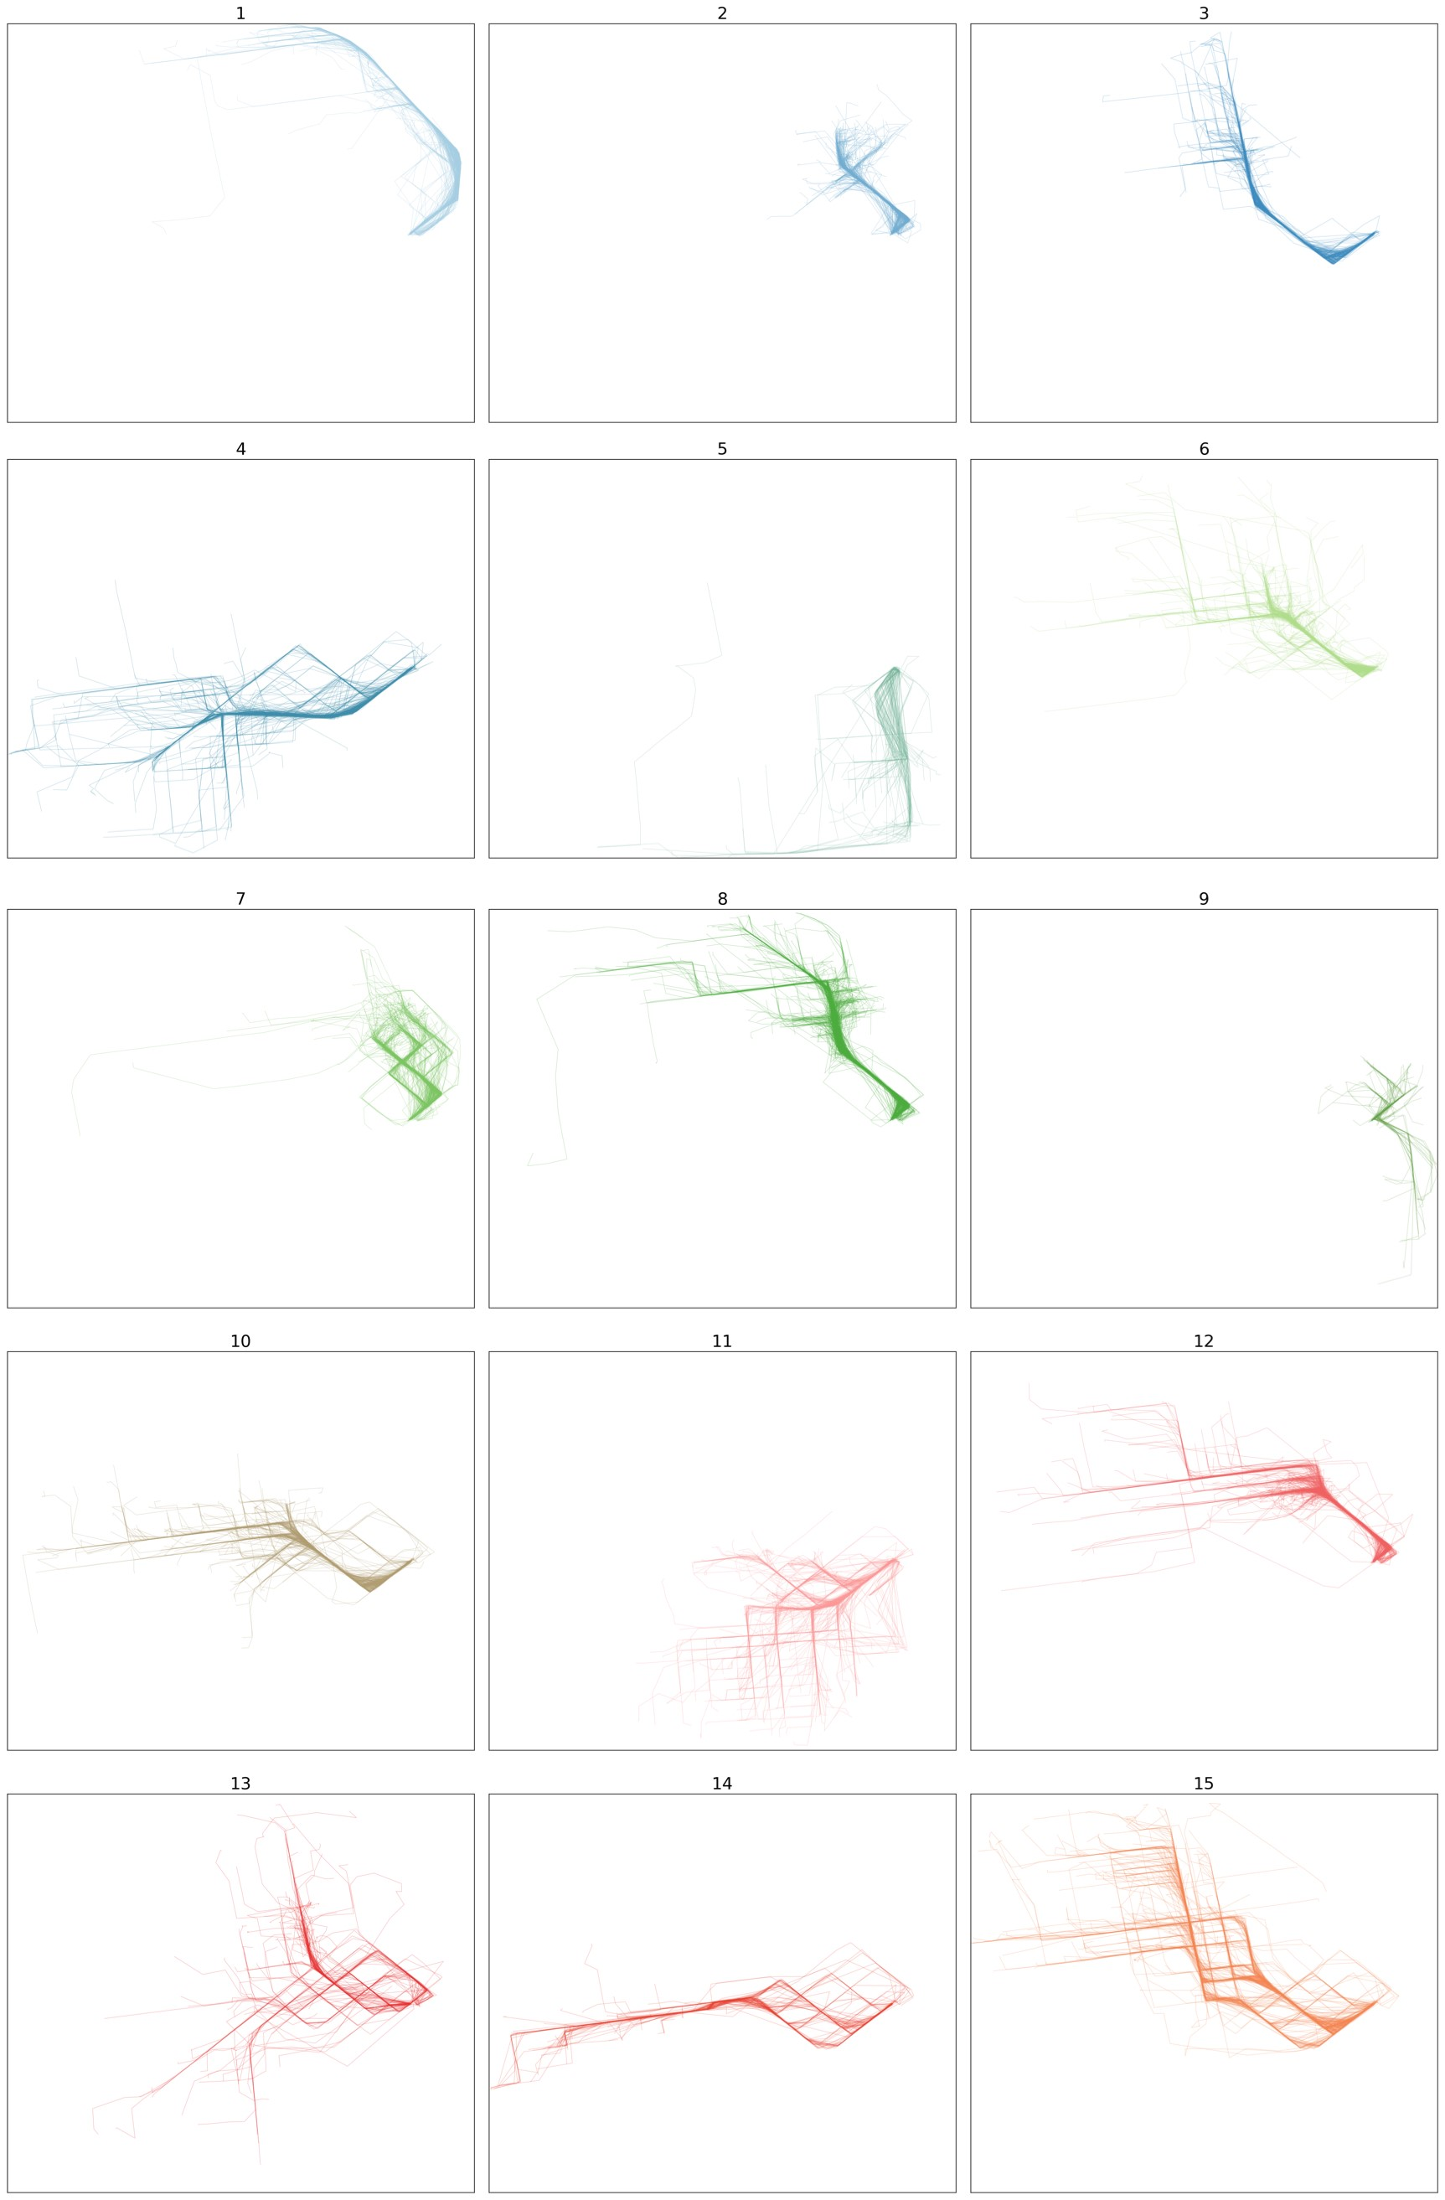

Figure 47: Caltrain HCSIM Clusters

# Conclustions

Clustering trajectories is heavily dependent on the selection of an appropriate distance. In this thesis, we explored several distances concentrating on various characteristics of trajectories. All distances seems work well with hierarchical agglomerative clustering (HAC) method to cluster trajectories. Based on our experiment, shape-based distances give a better clusters than warping-base ones, especially HC-SIM enable us obtain good clusters that nearly match groundtruth data. Both clustering and validation methods that we use in this thesis work well and give a good results. This may be used to address a variety of problems. From learning moving objects’ behavior, many applications are able to recommend locations to visit or arrange city’s trip based on that result.

References

Abbaspour, R. A., Shaeri, M., & Chehreghan, A. (2017). A method for similarity measurement in spatial trajectories. *Spatial Information Research*, *25*(3), 491– 500.

Aghabozorgi, S., Shirkhorshidi, A. S., & Wah, T. Y. (2015). Time-series clustering–a decade review. *Information Systems*, *53*, 16–38.

Ahmed, M., Karagiorgou, S., Pfoser, D., & Wenk, C. (2015). A comparison and evaluation of map construction algorithms using vehicle tracking data.

*GeoInformatica*, *19*(3), 601–632.

Atev, S., Masoud, O., & Papanikolopoulos, N. (2006). Learning traffic patterns at intersections by spectral clustering of motion trajectories. In *2006 ieee/rsj international conference on intelligent robots and systems* (pp. 4851–4856).

Ball, G. H., & Hall, D. J. (1965). *Isodata, a novel method of data analysis and pattern classification* (Tech. Rep.). Stanford research inst Menlo Park CA.

Banerjee, A., Dhillon, I. S., Ghosh, J., Sra, S., & Ridgeway, G. (2005). Clustering on the unit hypersphere using von mises-fisher distributions. *Journal of Machine Learning Research*, *6*(9).

Berkhin, P. (2006). A survey of clustering data mining techniques. In *Grouping multidimensional data* (pp. 25–71). Springer.

Besse, P., Guillouet, B., Loubes, J.-M., & François, R. (2015). Review and perspective for distance based trajectory clustering. *arXiv preprint arXiv:1508.04904*.

Biagioni, J., & Eriksson, J. (2012). Inferring road maps from global positioning system traces: Survey and comparative evaluation. *Transportation research record*, *2291*(1), 61–71.

Bian, J., Tian, D., Tang, Y., & Tao, D. (2019). Trajectory data classification:

A review. *ACM Transactions on Intelligent Systems and Technology (TIST)*, *10*(4), 1–34.

Burkard, R., Dell’Amico, M., & Martello, S. (2012). *Assignment problems: revised reprint*. SIAM.

Caliński, T., & Harabasz, J. (1974). A dendrite method for cluster analysis. *Communications in Statistics-theory and Methods*, *3*(1), 1–27.

Chen, J., Wang, R., Liu, L., & Song, J. (2011). Clustering of trajectories based on hausdorff distance. In *2011 international conference on electronics, communications and control (icecc)* (pp. 1940–1944).

Chen, M., Xu, M., & Franti, P. (2012). Compression of gps trajectories. In *2012 data compression conference* (pp. 62–71).

Chen, Z., Shen, H. T., Zhou, X., Zheng, Y., & Xie, X. (2010). Searching trajectories by locations: an efficiency study. In *Proceedings of the 2010 acm sigmod international conference on management of data* (pp. 255–266).

Cheng, Z., Jiang, L., Liu, D., & Zheng, Z. (2018). Density based spatio-temporal trajectory clustering algorithm. In *Igarss 2018-2018 ieee international geoscience and remote sensing symposium* (pp. 3358–3361).

Eiter, T., & Mannila, H. (1994). *Computing discrete fréchet distance.*

Ertöz, L., Steinbach, M., & Kumar, V. (2003). Finding clusters of different sizes, shapes, and densities in noisy, high dimensional data. In *Proceedings of the 2003 siam international conference on data mining* (pp. 47–58).

Ester, M., Kriegel, H.-P., Sander, J., Xu, X., et al. (1996). A density-based algorithm for discovering clusters in large spatial databases with noise. In *Kdd* (Vol. 96, pp. 226–231).

Faloutsos, C., Ranganathan, M., & Manolopoulos, Y. (1994). Fast subsequence matching in time-series databases. *Acm Sigmod Record*, *23*(2), 419–429.

Fowlkes, E. B., & Mallows, C. L. (1983). A method for comparing two hierarchical clusterings. *Journal of the American statistical association*, *78*(383), 553–569.

Fränti, P. (2018). Efficiency of random swap clustering. *Journal of Big Data*, *5*(1), 1–29.

Fränti, P., & Mariescu-Istodor, R. (2021). Averaging gps segments competition 2019. *Pattern Recognition*, *112*, 107730.

Fränti, P., & Sieranoja, S. (2018). K-means properties on six clustering benchmark datasets. *Applied Intelligence*, *48*(12), 4743–4759.

Fränti, P., & Sieranoja, S. (2019). How much can k-means be improved by using better initialization and repeats? *Pattern Recognition*, *93*, 95–112.

Gaffney, S., & Smyth, P. (1999). Trajectory clustering with mixtures of regression models. In *Proceedings of the fifth acm sigkdd international conference on knowledge discovery and data mining* (pp. 63–72).

Gariel, M., Srivastava, A. N., & Feron, E. (2011). Trajectory clustering and an application to airspace monitoring. *IEEE Transactions on Intelligent Transportation Systems*, *12*(4), 1511–1524.

Han, J., Pei, J., & Kamber, M. (2011). *Data mining: concepts and techniques*.

Elsevier.

Hartigan, J. A. (1975). *Clustering algorithms*. John Wiley & Sons, Inc.

Ignacio Gonzalez, S. L., et al. (2017). Hierarchical clustering tutorial [Computer software manual]. Retrieved from [http://genoweb.toulouse.inra.fr/ ~formation/CATIBIOS4BIOL_stats/Learning_clustering_current.pdf](http://genoweb.toulouse.inra.fr/~formation/CATIBIOS4BIOL_stats/Learning_clustering_current.pdf)

Jain, A. K., Murty, M. N., & Flynn, P. J. (1999). Data clustering: a review.

*ACM computing surveys (CSUR)*, *31*(3), 264–323.

Kearney, J. K., & Hansen, S. (1990). *Stream editing for animation.*

Keogh, E. J., & Pazzani, M. J. (2000). Scaling up dynamic time warping for datamining applications. In *Proceedings of the sixth acm sigkdd international conference on knowledge discovery and data mining* (pp. 285–289).

Kriegel, H.-P., Kröger, P., Sander, J., & Zimek, A. (2011). Density-based clustering. *Wiley Interdisciplinary Reviews: Data Mining and Knowledge Discovery*, *1*(3), 231–240.

Kruskal, J. B. (1983). An overview of sequence comparison: Time warps, string edits, and macromolecules. *SIAM review*, *25*(2), 201–237.

Krzanowski, W. J., & Lai, Y. (1988). A criterion for determining the number of groups in a data set using sum-of-squares clustering. *Biometrics*, 23–34.

Kuhn, H. W. (1955). The hungarian method for the assignment problem. *Naval research logistics quarterly*, *2*(1-2), 83–97.

Lee, J.-G., Han, J., & Whang, K.-Y. (2007). Trajectory clustering: a partitionand-group framework. In *Proceedings of the 2007 acm sigmod international conference on management of data* (pp. 593–604).

Liu, S., Ni, L. M., & Krishnan, R. (2013). Fraud detection from taxis’ driving behaviors. *IEEE Transactions on Vehicular Technology*, *63*(1), 464–472.

Malinen, M. I., & Fränti, P. (2014). Balanced k-means for clustering. In *Joint iapr international workshops on statistical techniques in pattern recognition (spr) and structural and syntactic pattern recognition (sspr)* (pp. 32–41).

Malinen, M. I., Mariescu-Istodor, R., & Fränti, P. (2014). K-means∗: Clustering by gradual data transformation. *Pattern Recognition*, *47*(10), 3376–3386.

Mariescu-Istodor, R. (2013). Detecting user actions in mopsi. *University of Eastern Finland School of Computing Thesis*.

Mariescu-Istodor, R., & Fränti, P. (2017). Grid-based method for gps route analysis for retrieval. *ACM Transactions on Spatial Algorithms and Systems (TSAS)*, *3*(3), 1–28.

Mariescu-Istodor, R., & Fränti, P. (2018). Cellnet: Inferring road networks from gps trajectories. *ACM Transactions on Spatial Algorithms and Systems (TSAS)*, *4*(3), 1–22.

Meilă, M. (2003). Comparing clusterings by the variation of information. In *Learning theory and kernel machines* (pp. 173–187). Springer.

Myers, C., Rabiner, L., & Rosenberg, A. (1980). Performance tradeoffs in dynamic time warping algorithms for isolated word recognition. *IEEE Transactions on Acoustics, Speech, and Signal Processing*, *28*(6), 623–635.

Nallusamy, R., Duraiswamy, K., Dhanalaksmi, R., & Parthiban, P. (2010). Optimization of non-linear multiple traveling salesman problem using k-means clustering, shrink wrap algorithm and meta-heuristics. *International Journal of Nonlinear Science*, *9*(2), 171–177.

Pfeifer, P. E., & Deutrch, S. J. (1980). A three-stage iterative procedure for space-time modeling phillip. *Technometrics*, *22*(1), 35–47.

Piorkowski, M., Sarafijanovic-Djukic, N., & Grossglauser, M. (2009). *Crawdad data set epfl/mobility (v. 2009-02-24).*

Priestley, M. (1980). State-dependent models: A general approach to non-linear time series analysis. *Journal of Time Series Analysis*, *1*(1), 47–71.

Qian, H., & Lu, Y. (2017). Simplifying gps trajectory data with enhanced spatialtemporal constraints. *ISPRS International Journal of Geo-Information*, *6*(11), 329.

Rezaei, M., & Fränti, P. (2016). Set matching measures for external cluster validity. *IEEE Transactions on Knowledge and Data Engineering*, *28*(8), 2173– 2186.

Rezaei, M., & Franti, P. (2018). Real-time clustering of large geo-referenced data for visualizing on map. *Advances in Electrical and Computer Engineering*, *18*(4), 63–74.

Rodriguez, A., & Laio, A. (2014). Clustering by fast search and find of density peaks. *science*, *344*(6191), 1492–1496.

Rousseeuw, P. J. (1987). Silhouettes: a graphical aid to the interpretation and validation of cluster analysis. *Journal of computational and applied mathematics*, *20*, 53–65.

Siavoshi, S., Kavian, Y. S., & Sharif, H. (2016). Load-balanced energy efficient clustering protocol for wireless sensor networks. *IET Wireless Sensor Systems*, *6*(3), 67–73.

Sieranoja, S., & Fränti, P. (2019). Fast and general density peaks clustering. *Pattern Recognition Letters*, *128*, 551–558.

Su, H., Liu, S., Zheng, B., Zhou, X., & Zheng, K. (2020). A survey of trajectory distance measures and performance evaluation. *The VLDB Journal*, *29*(1), 3–32.

Sultana, S. I. (2020). How the hierarchical clustering algorithm works [Computer software manual]. Retrieved from [https://dataaspirant.com/hierarchical](https://dataaspirant.com/hierarchical-clustering-algorithm/)

[-clustering-algorithm/](https://dataaspirant.com/hierarchical-clustering-algorithm/)

Van Rijsbergen, C. (1979). Information retrieval: theory and practice. In *Proceedings of the joint ibm/university of newcastle upon tyne seminar on data base systems* (pp. 1–14).

Vasquez, D., & Fraichard, T. (2004). Motion prediction for moving objects: a statistical approach. In *Ieee international conference on robotics and automation, 2004. proceedings. icra’04. 2004* (Vol. 4, pp. 3931–3936).

Waga, K., Tabarcea, A., Chen, M., & Fränti, P. (2012). Detecting movement type by route segmentation and classification. In *8th international conference on collaborative computing: networking, applications and worksharing (collaboratecom)* (pp. 508–513).

Wang, H., Su, H., Zheng, K., Sadiq, S., & Zhou, X. (2013). An effectiveness study on trajectory similarity measures. In *Proceedings of the twenty-fourth australasian database conference-volume 137* (pp. 13–22).

Xu, L. (1997). Bayesian ying–yang machine, clustering and number of clusters. *Pattern Recognition Letters*, *18*(11-13), 1167–1178.

Xu, R., & Wunsch, D. (2005). Survey of clustering algorithms. *IEEE Transactions on neural networks*, *16*(3), 645–678.

Ying, J. J.-C., Lee, W.-C., Weng, T.-C., & Tseng, V. S. (2011). Semantic trajectory mining for location prediction. In *Proceedings of the 19th acm sigspatial international conference on advances in geographic information systems* (pp. 34–43).

Ying, J. J.-C., Lu, E. H.-C., Lee, W.-C., Weng, T.-C., & Tseng, V. S. (2010). Mining user similarity from semantic trajectories. In *Proceedings of the 2nd acm sigspatial international workshop on location based social networks* (pp. 19–26).

Yuan, G., Sun, P., Zhao, J., Li, D., & Wang, C. (2017). A review of moving object trajectory clustering algorithms. *Artificial Intelligence Review*, *47*(1), 123–144.

Zhao, L., & Shi, G. (2019). A trajectory clustering method based on douglaspeucker compression and density for marine traffic pattern recognition. *Ocean Engineering*, *172*, 456–467.

Zhao, Q., & Fränti, P. (2014). Wb-index: A sum-of-squares based index for cluster validity. *Data & Knowledge Engineering*, *92*, 77–89.

Zhao, Q., Shi, Y., Liu, Q., & Fränti, P. (2015). A grid-growing clustering algorithm for geo-spatial data. *Pattern Recognition Letters*, *53*, 77–84.

Zhao, Q., Xu, M., & Fränti, P. (2008). Knee point detection on bayesian information criterion. In *2008 20th ieee international conference on tools with artificial intelligence* (Vol. 2, pp. 431–438).

Zhao, Q., Xu, M., & Fränti, P. (2009). Sum-of-squares based cluster validity index and significance analysis. In *International conference on adaptive and natural computing algorithms* (pp. 313–322).

Zhao, Y., & Karypis, G. (2001). Criterion functions for document clustering: Experiments and analysis.

Zhong, C., Miao, D., & Wang, R. (2010). A graph-theoretical clustering method based on two rounds of minimum spanning trees. *Pattern Recognition*, *43*(3), 752–766.

Zhong, S., & Ghosh, J. (2003). Model-based clustering with soft balancing. In *Third ieee international conference on data mining* (pp. 459–466).